1st Experimental Primary School
of Alexandroupolis
Project plan

Subject : Learning about the Holocaust & Human Rights

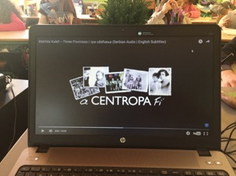
Project work: Duration 6 months
Grade : Third Grade
Age: 9 years old
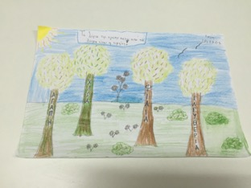
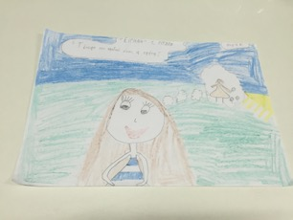
Class Teacher :
Doulami Evgenia
(Primary School
Teacher)

22 sessions with the class teacher

Alexandroupolis 2015 - 2016
PROCESSING THE SUBJECT
The subject: "Learning about the Holocaust and Human Rights" was selected as part of a school activity program and particularly as part of the lesson, "The Joy of Reading", it was approached interdisciplinary and disseminated in all subjects. The basic purpose is to talk, discuss and learn about the holocaust and human rights and how they should be considered inviolable and respected by all the people.
The pedagogical objectives are:
* To mobilize the interest and feelings of children for concepts such as the holocaust, human rights, solidarity and intolerance
* To reflect on discrimination against people with different identities
* To cultivate critical attitude towards behaviors that oppose equality of people
The approach of this subject began during the lesson of Greek language and literature: "1st Unit / Chapter 5th: "In the war of 1940". This chapter reports on testimonies of the difficult years during the war and greek occupation. Particularly this chapter includes excerpt and photos from the diary of Rosina Pardo, a ten year old Jewish girl from Thessaloniki. This text gave us the incentive to investigate the evidence and to begin a dialogue with the young pupils, in order to formulate questions about these specific historical events and to establish the sharing of a program related to the holocaust and human rights.

THE CLASS
The second class of the third Grade (Γ΄2) of the Experimental Primary School in Alexandroupolis consists of 19 students (10 girls and 9 boys).
METHODOLOGY:
Starting from the fact that the education of moral values begins in elementary school, during their formative years, pupils in younger grades often develop opinions and beliefs that they will carry with them to the rest of their lives, we selected to implement a creative interdisciplinary project focused on issues such as human rights, fighting of intolerance and anti-Semitism. This project includes film presentations, which narrate stories of children from different countries (Greece, Poland, the Czech Republic, Serbia), who survived from the Holocaust and they testified their experiences. Alongside the films as well as the corresponding material, an account of the events of the period is included, focusing on the victims' hardships, pain, faith, optimism and coping mechanisms. As the children grow older, they better understand the complexity of the subject matter. Over time, they will learn that despite the attempts to overcome and endure the difficulties, the vast majority of the Jews perished. Nevertheless, instead of developing a sense of devastation and helplessness, they will empathize on the actions and hopes of the people who lived during that time.
For the presentation and analysis of the subject the interdisciplinary approach was chosen, because the pupils at this age tire easily and may constantly need new stimuli, so they can delve into a subject with many facets. So creative writing activities were designed and the subjects of art and environmental studies were used, which will be analyzed in the following stages of the project.
PEDAGOGICAL GUIDELINES:
The following four guidelines were kept in mind when teaching the Holocaust to younger children:
- Through micro history a personal story should be told, focusing on identifiable characters to the children (that's why we selected to present 4 different stories of children that they survived from the Holocaust). This will allow the pupils to see the story through their eyes and empathize with difficulties and dilemmas that people faced during that period.
- Acquaintance with the Righteous among the Nations and Jews who tried to help others even at risk to themselves and their loved ones. Humane deeds and acts of kindness, as well as attempts to overcome obstacles in a time of evil and terror are highlighted.
- Authenticity with respect to the narrative, values and history. We tried to approach the material and teach it in a pertinent, age-appropriate manner, without mystifying the protagonists or demonizing the antagonists.
- The subject was taught by the teacher of the class, because she has an established relationship with the pupils. It is important that the educator gives pupils a sense of security as they become acquainted with this difficult subject.

1st Unit: ROSINA PARDO
As mentioned above, the approach of the subject began from the lesson of Greek language and literature: "1st Unit / Chapter 5th: "In the war of 1940". This chapter reports testimonies of the difficult years of war and greek occupation. Particularly this chapter includes excerpts and photos from the diary of Rosina Pardo, a ten year old Jewish girl from Thessaloniki. This chapter starts from October 1940 with the declaration of the war and closes in October 1944 with the liberation of Thessaloniki. At the same period the captivity of Rosina and her family ceases when they are "released" from the hiding place that doctor Karakotsos provided them within his apartment. Also, this story introduces for the fist time to the young pupils the term "Righteous Among the Nations". The story highlights a Greek family's ongoing commitment to the welfare of a Jewish family, even at the risk of their own personal safety. These exemplary people reinforce the awareness that acts of kindness are due to one's education and values that do not change or disappear even in times of great danger.
This unit consists of 3 sessions and last 6 teaching hours.
1st SESSION (2 hours)
Subject: Teaching Chapter 5: «In the war of 1940», 1st Unit of Greek language book of Third Grade (issue 1)
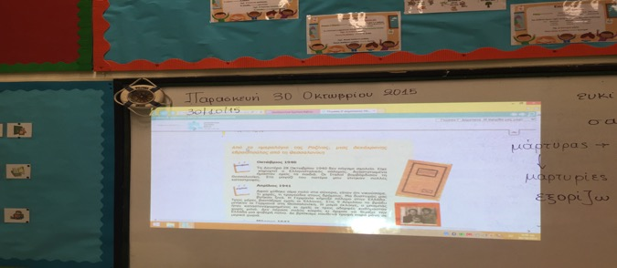

Aim :
- To mobilize the interest and feelings of pupils about the specific historical events
Objectives: The young pupils will:
- learn what form a diary has
- approach historical evidence from the war of 1940 in Greece
- formulate questions and queries about specific historical events
- express feelings
- gather information on these events
- seize evidence related to how the nearby relatives lived the events
Method: exploratory learning (dialogue, demonstration, brainstorming, guided conversation)
Teaching procedure:
- Comment on the picture and the course title
- Speculate on Rosina's diary
- Processing the diary
- Formulate questions for gathering information and looking into the text
- Complete the "Pardo family" diagram
- Complete the "Events" diagram according to Rosina's diary
- Describe images that pupils will have in mind after reading the diary
Materials:
  - Laptop, video projector
  - Pupil's book

  - "Pardo family" diagram
PARDO FAMILY

Father
Mother

Children

  - "Events" diagram

October of 1940

April of 1941

March of 1943

October of 1944

2^{ηd} SESSION (2 hours)
Subject: Watching a video with Rosina's Pardo interview
Aim :
- To focus on telling a personal story, through watching an interview
Objectives: The young pupils will:
- focus on Rosina's Pardo identifiable character, in order to appropriate her personal story
- focus on Rosina's difficulties and dilemmas
- present information, that they gathered for this period
- present evidence related to how the nearby relatives lived these events
Method: exploratory learning (demonstration, dialogue, guided conversation)
Teaching procedure:
- Reflection on previous session - discussion
- Presentation of video
- Formulate questions to gather information about the degree of understanding the video
- Resolve questions
- Presentation project from the pupils themselves
- Discussion
Materials:
  - Laptop, video projector
  - Video: https://www.youtube.com/playlist?list=PL2J_qoFbHd55zN5pBOLN-I7Gk5ORRgtYQ
«Το Ολοκαύτωμα και οι Έλληνες Εβραίοι» - Εκπαιδευτήρια Μαντουλίδη
- Printed material that pupils brought
- Recorded conversation concerning pupil's grandmother and her experiences from the war of 1940

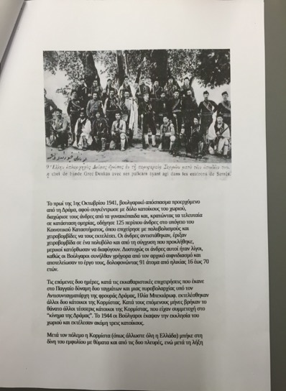
Pupil's project - Printed material:
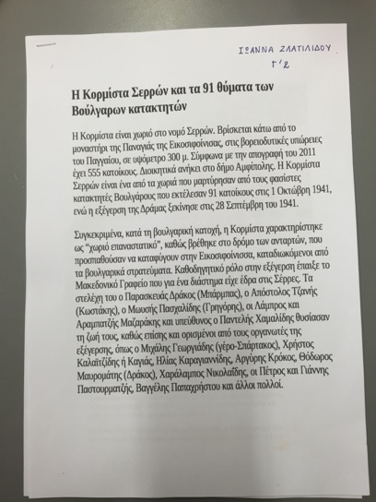
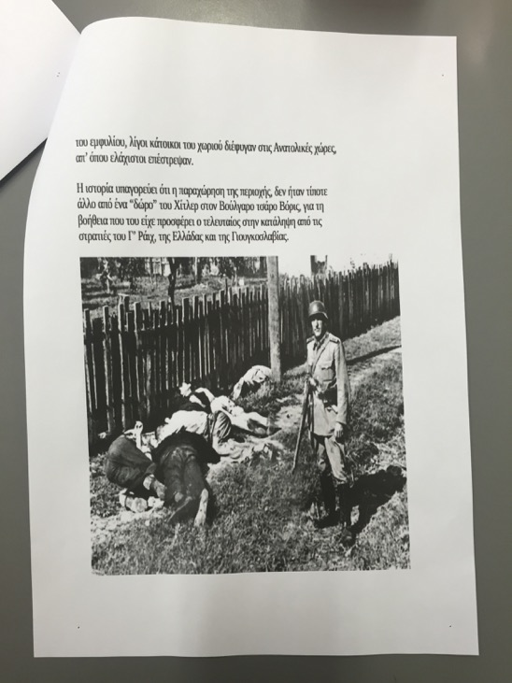

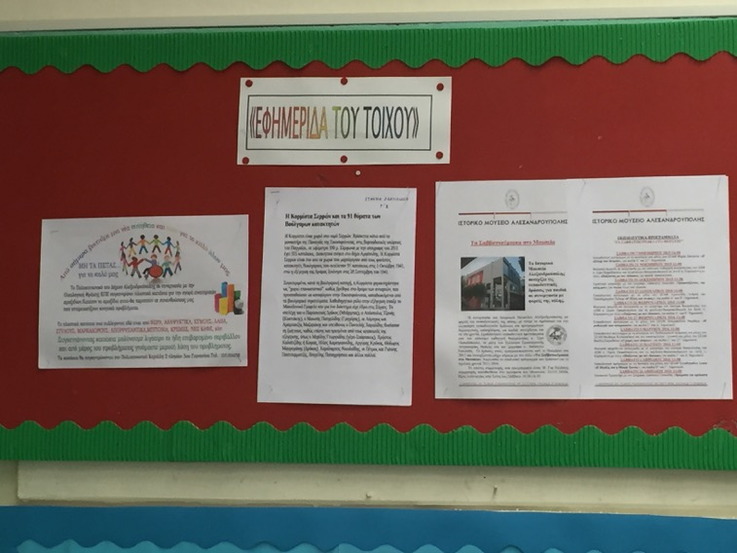

Posted on the class wall newspaper

3rd SESSION (2 hours)
Subject: Teaching Chapter 2 /Unit 6 of environmental studies book of Third Grade that describes human rights and particularly children rights
Aim :
- To mobilize the interest and the feelings of the pupils on human rights
Objectives: The young pupils will:
- learn the meaning of human rights
- recognize the right of child protection
- work creatively, in order to cultivate creative thinking
Method: exploratory learning (demonstration, dialogue, guided conversation, creative work)
Teaching procedure:
- Annotation of the text
- Formulation of pupil's view on the concept "right" generally and especially about "human rights", which must be considered inviolable and respected by all the people
- Filling in the book of children's rights
- Formulation and completion of the questions by the pupils on their workbooks
- Formulation and completion of proposals by the pupils on their workbooks
- Artistic expression activity: "create a hand with the rights of children"
Materials:
  - Laptop, video projector
  - Pupil's book & workbook
  - Photocopy of the charter of children's rights (A3)
  - Cartons of various colors cut into hand shape
  - Colored markers

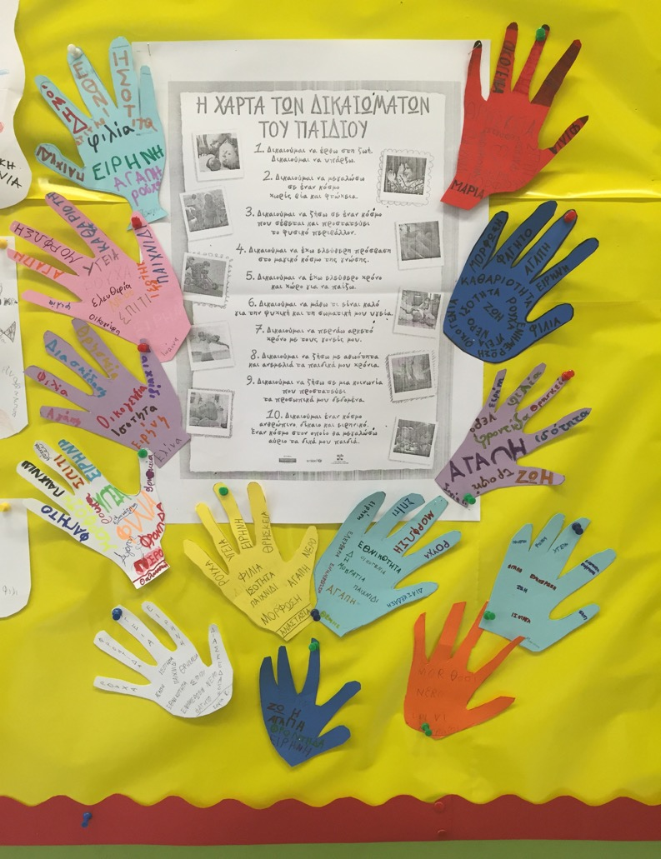
The charter of children's rights

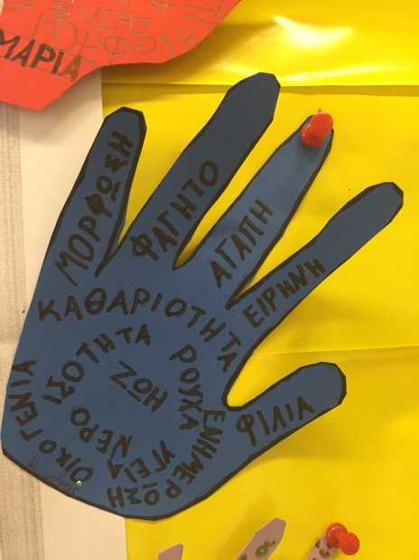
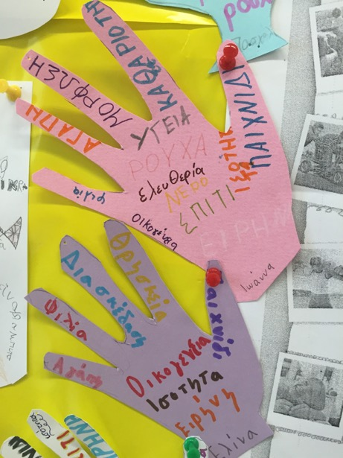

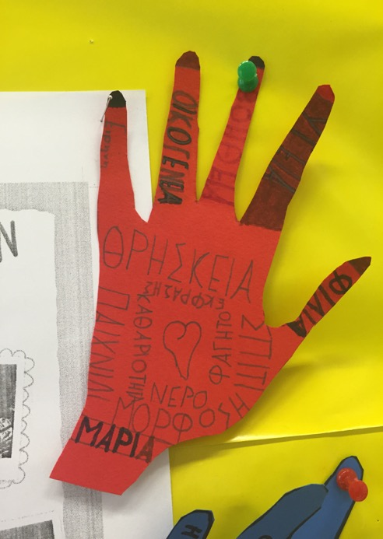
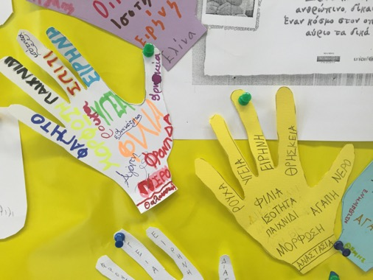

Concepts such as equality,
peace, education, love,
family, friendship, play,
fun, health, cleanness,
freedom, food e.t.c.

2^{ηd} Unit: I WANT TO FLY LIKE A BUTTERFLY
In this unit we read in the greek language, in electronic form, the book: : " I want to fly like a butterfly". This book is based on the testimony of a Holocaust survivor and describes the story of a young girl, Hanechka, from Poland. The story is narrated in the first person and young pupils are in constant suspense, waiting to know how it will develop. The tension is cased throughout the story by the fact that the student knows that the narrator survived. The story interweaves the survivor's personal story, from which one can learn about how some people were able to maintain their moral framework and value systems, even during this dark period. The observations and the actions of the narrator, as well as her desire and ability to find the optimistic, hopeful side in so many difficult situations, provide the basis for an age-appropriate foundation to teach the Holocaust in younger children. In addition, the story illustrates how even people with tremendous personal concerns, may still take an active role in helping others, as in the case of the preparation of soup for other less fortunate Jews living in ghetto. Also, this story reminds to the young pupils the term "Righteous Among the Nations". Particularly, this story highlights a Polish family's (Skovroneck family) ongoing commitment to the welfare of a Jewish mother and her daughter, even at the risk of their own personal safety. A sense of optimism and hope is interwoven throughout the story. The end of the story illustrates the tremendous changes and upheavals so many people had to endure after Holocaust, in order to rebuild themselves and return to life.
This unit consists of 3 sessions and last 6 teaching hours.

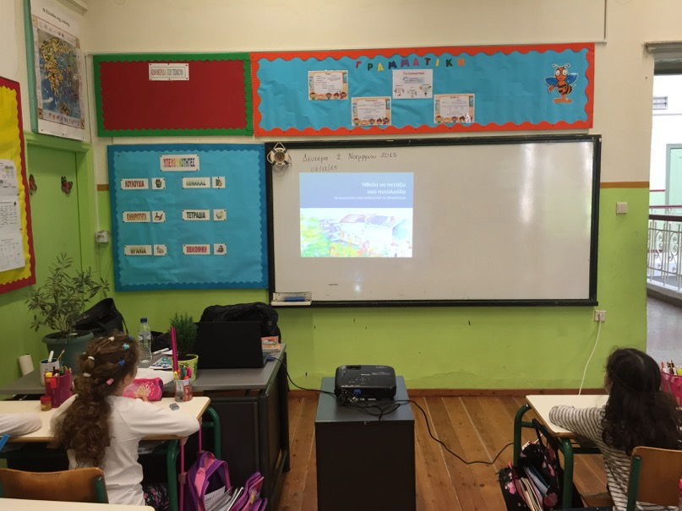

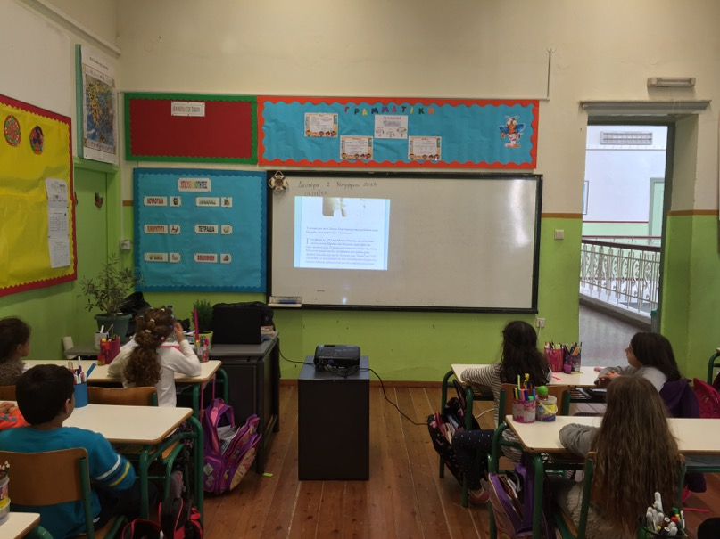

1st SESSION (2 hours)
Subject: In "The Joy of Reading" lesson we read and see the story: "I want to fly like a butterfly"
Aim :
- To mobilize the interest and feelings of pupils about Hanechka's
story
Objectives: The young pupils will:
- watch what was the everyday life of a young child in Poland before the war
- learn how this life changed after the outbreak of the war and the occurrence of the Nazis (yellow star, restrictions, isolation, evictions, hiding)
- learn the Jewish religion (Jewish religion days - Synagogue)
- "meet" the term "ghetto"
- "see" the life after the Holocaust
Method: exploratory learning (demonstration, dialogue, guided conversation)
Teaching procedure:
- Monitoring and simultaneous reading of e-book: "I want to fly like a butterfly"
- Analysis, processing and annotation of the story
- Questions from the pupils - discussion
- Express emotions for the heroine and her story by the pupils
Materials:
  - Laptop, video projector
  - e-book : "I want to fly like a butterfly" in greek version
  - Book : "I want to fly like a butterfly" in english version
Pupil's paintings for this story:
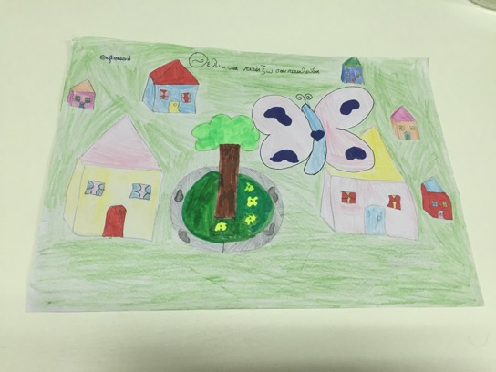

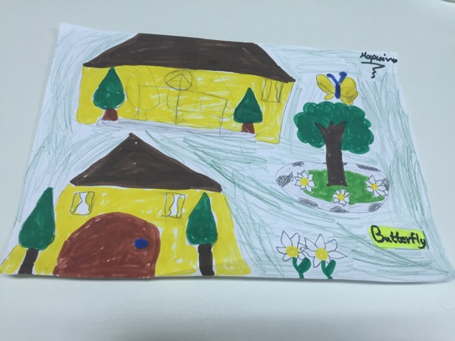

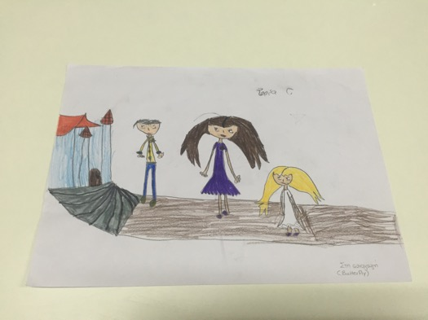

Going to Synagogue...

2nd SESSION (2 hours)
Subject: Highlight the point mentioned about the Skovroneck family, who hosted Hanechka and her mother during the difficult period of war - Poem processing
Aim : To mobilize the interest and the feelings of the pupils for the family that saved Hanechka
Objectives: The young pupils will:
- "meet" again the term: "Righteous among the Nations"
- read and discuss the Hebrew poem: "Plant of Flowers" of Chaim Nachman Bialik, in greek version
- express and discuss about their emotions after the reading of the poem
Method: exploratory learning (demonstration, dialogue, guided conversation)
Teaching procedure:
  - Discussion about Skovroneck family
  - Remind the term: "Righteous among the Nations"
  - Questions from the pupils - discussion
  - Highlight the point in the story, where Hanechka creeps under the window and overhears the voices of young children play in the yard (p. 26), as well as the point that Hanechka looks after the potted plants that Mrs. Skovroneck gave her and grows them under the window
  - Presentation and processing of the poem: "Plant of Flowers" of Chaim Nachman Bialik
  - Highlight the relation between Hanechka's situation and the plants as presented in the poem
Materials:
  - Laptop, video projector
  - e-book : "I want to fly like a butterfly" in greek version
  - Poem : "Plant of Flowers" of Chaim Nachman Bialik in greek version
3rd SESSION (2 hours)
Subject: Plant crocus (plants) from the programme "Crocus" of Jewish Museum in Greece
Aim : Plant yellow crocus for the memory of 1,5 million Jewish children, that lost their life in the Holocaust
Objectives: The young pupils will:
- honor the memory of the children, who perished in the Holocaust
- send messages of love, optimism and peace
- learn to plant and look after plants and watch their development
- work creatively, in order to cultivate creative thinking
Method: exploratory learning
Teaching procedure:

  - Artistic expression activity: Create a crocus with my name
  - Plant crocuses
Materials:
  - Carton of yellow and green color cut into crocus shape
  - Wooden sticks
  - Coloured markers
  - Glue
  - Pots, seeds, soil, gloves, water

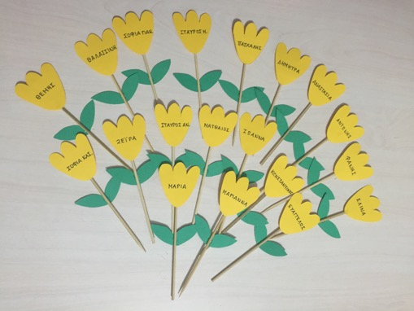
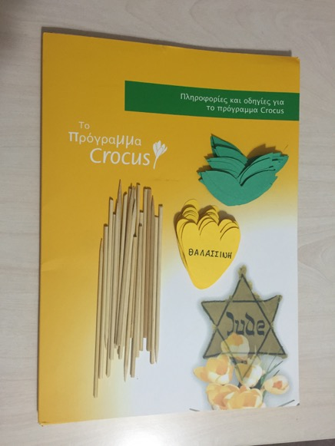

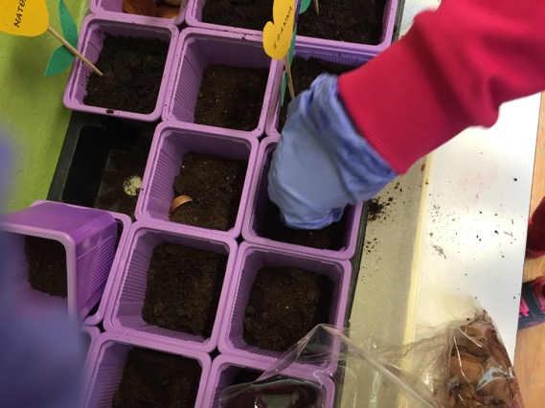
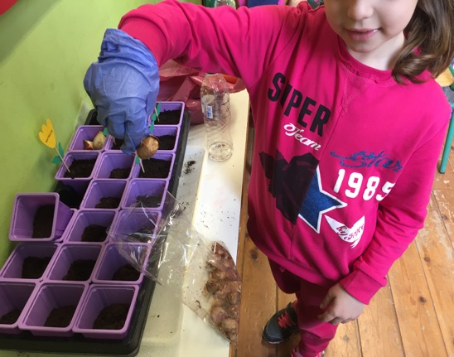

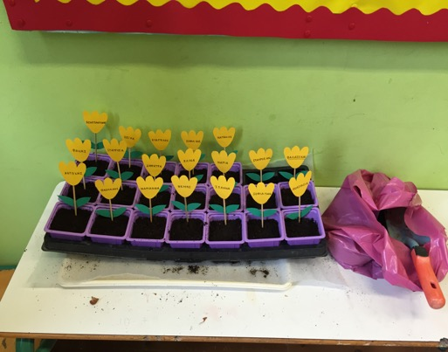
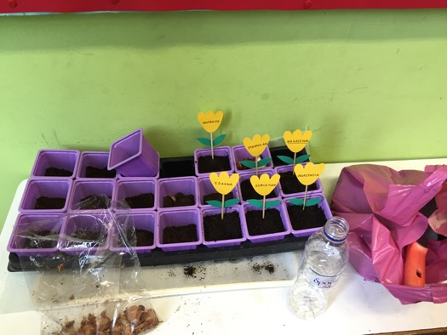
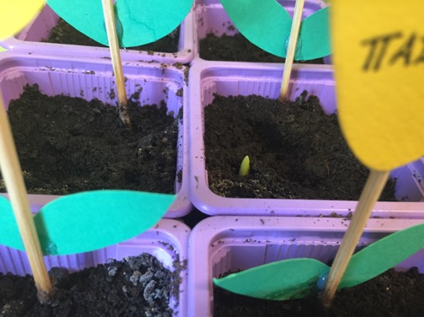

The first crocus sprang
3^{ηd} Unit: Dagmar Lieblova "From Bohemia to Belsen...and back again"
In this unit we watched the film: Dagmar Lieblova "From Bohemia to Belsen...and back again", from Centropa website, in greek translation . This film is also based on the testimony of a Holocaust survivor and describes the story of a girl, Dagmar, from the Czech Republic. The story, as the previous one, is told in the first person and pupils are in constant suspense, waiting to know how it will develop. The tension is cased throughout the story by the fact that the student knows that the narrator survived. The story starts from the period before the war, where the narrator presents the family story, as well as the way in which her parents met each other. Then Dagmar describes their ordeals, in order to survive this difficult and dark period. So pupils learn the difficulties "faced" by the family, starting from the town, where they live, then in ghetto Terezin, in Auschwitz-Birkenau concentration camp and finally at Bergen-Belsen. Throughout the story, the narrator highlights the support provided by the cook and then the nanny of family children, Fanynka, who finally keeps the family property until the end of the war. Subsequently, this strong woman, Fanynka, will be the "mainstay" of Dagmar, who is the only survivor of the family from the Holocaust, when she returns at home. She will provide full support to Dagmar's Lieblova new start.
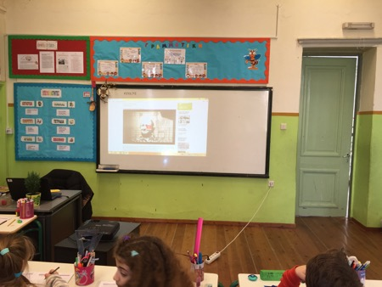
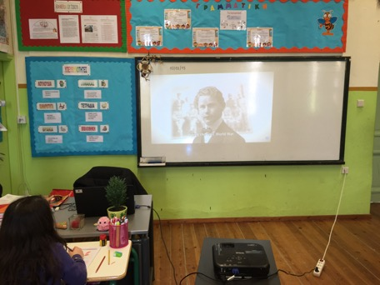
This unit consists of 2 sessions and last 4 teaching hours.
1st SESSION (2 hours)
Subject: In "The Joy of Reading" lesson we watch the story: Dagmar Lieblova "From Bohemia to Belsen...and back again", from Centropa website, in greek translation, highlighting the most important points.
Aim :
- To mobilize the interest and feelings of pupils about Dagmar's
Lieblova story
Objectives: The young pupils will:
- watch the family story of a young child in the Czech Republic before the war
- learn how this life changed after the outbreak of the war, as well as the laws and the restrictions imposed on them
- watch how the life in a ghetto was and particularly in Terezin
- watch the difficulties "faced" by the family in the Aushwitz - Birkenau concentration camp and the later state of the narrator in Bergen - Belsen concentration camp.
- observe the "moral" code of values of exemplary people (Fanynka)
- "see" the life after the Holocaust
Method: exploratory learning (demonstration, dialogue, guided conversation)
Teaching procedure:
- Presentation and monitoring of film: Dagmar Lieblova "From Bohemia to Belsen...and back again" in greek translation
- Formulate questions to gather information about the degree of understanding the video
- Analysis, processing and annotation of the story
- Questions from the pupils - discussion
- Express emotions for the heroine and her story by the pupils
- Complete the "Fantl family" diagram
Materials:
  - Laptop, video projector
  - Film : Dagmar Lieblova "From Bohemia to Belsen...and back again" from Centropa website:
http://www.centropa.org/node/44639?subtitle_language=
  - Family's diagram:
FANTL
FAMILY

Mother
Father

Children

2nd SESSION (2 hours)
Subject: Talking about human values
Aim :
- To learn and discuss about human values
Objectives: The young pupils will:
- discuss the meaning of human values
- enumerate human values
- recognize that the values of life arise from our need to coexist harmoniously with others
- recognize that when we have values we can live better
- report values to coexist harmoniously in our class
- work creatively, in order to cultivate creative thinking
Method: exploratory learning (demonstration, dialogue, guided conversation, creative work)
Teaching procedure:
- Formulation of pupil's view on concept "human values"
- Clarification - Commentary
- Name human values (brainstorming)
- Name values, that are important to coexist harmoniously in class (brainstorming)
- Artistic expression activity: Create and paint the values reported by our class
Materials:
  - Whiteboard - markers
  - Cartons of various colors cut into rectangular shape
  - Colored markers
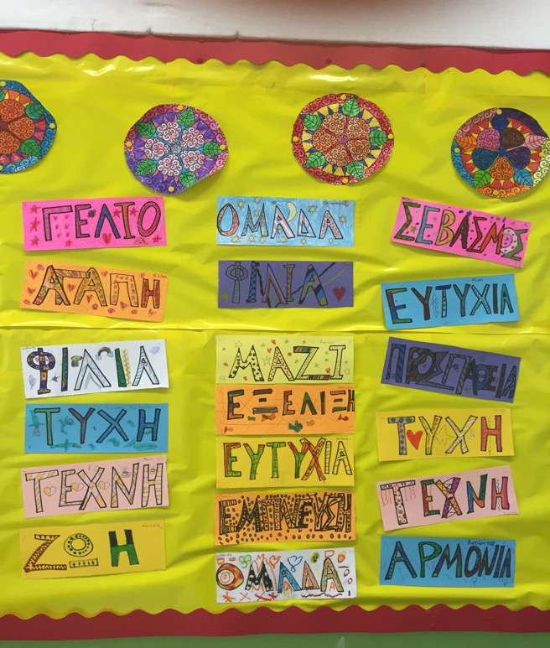

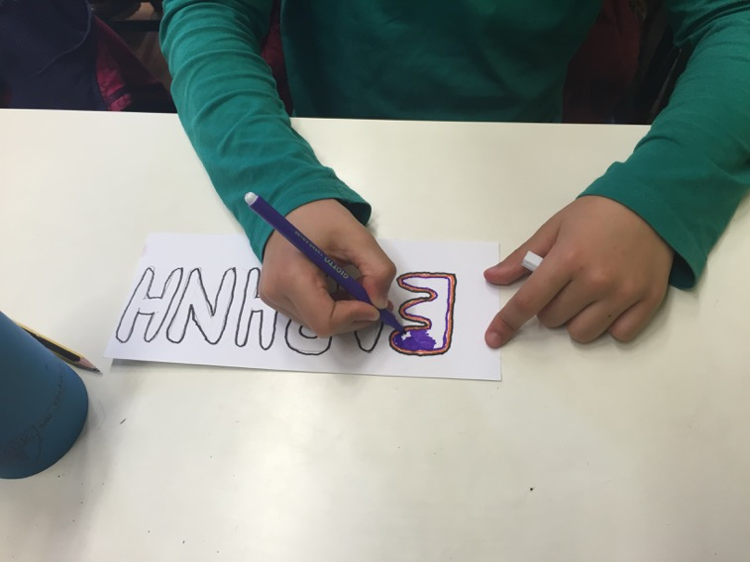

Create and paint values such as "peace"

4th Unit: Matilda Kalef "Three promises"
In this unit we watched the film: Matilda Kalef "Three promises", from Centropa website, in greek translation . This film is also based on the testimony of a Holocaust survivor and describes the story of a girl, Matilda, from Serbia. The story, as well as the previous one, is told in the first person and pupils are in constant suspense, waiting to know how it will develop. The tension is cased throughout the story by the fact that the student knows that the narrator survived. The story initially focuses on promises and then describes the history of the family and the carefree life before the war. This beautiful and peaceful period is interrupted by the start of the war and the ordeals that the family had to face. The greatest ordeal is the deteriorating of their father's health. At this point the first promise is given between the mother and the father of the family. An important person that is referred in the narration, is the Slovenian Catholic priest Father Andrej Tumpej, to whom the mother turned to in order to protect her daughters in this dark period of the Holocaust. At that point, also the other two promises are given, one between the priest and the mother and the other between the girls.
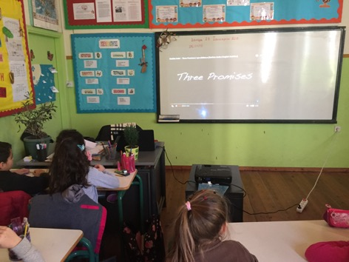
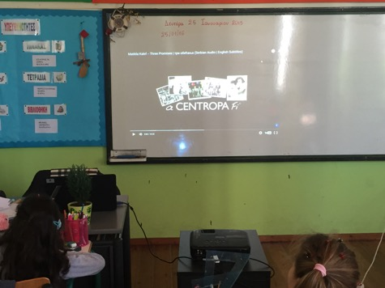
This unit consists of 2 sessions and last 6 teaching hours.

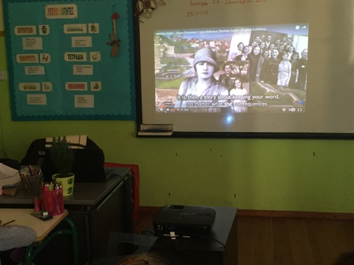

1st SESSION (2 hours)
Subject: In "The Joy of Reading" lesson we watch the story: Matilda Kalef "Three promises", from Centropa website, in greek translation, highlighting the most important points.
Aim :
- To mobilize the interest and feelings of pupils about Matilda Kalef's story
Objectives: The young pupils will:
- watch the family story of two sisters in Serbia before the war
- learn how this life changed after the outbreak of the war
- focus on three promises and be able to name them
- observe the "moral" code of values of exemplary people (Father Andrej Tumpej)
- discuss again about the "Righteous Among the Nations"
- find similarities and differences between Rosina, Hanechka, Dagmar and Matilda.

Method: exploratory learning (demonstration, dialogue, guided conversation)
Teaching procedure:
- Presentation and monitoring of the film: Matilda Kalef "Three promises", in greek translation
- Formulate questions to gather information about the degree of understanding the video
- Analysis, processing and annotation of the story
- Questions from the pupils - discussion
- Express emotions for the heroine and her story by the pupils
- Complete the "Three promises" diagram
Materials:
  - Laptop, video projector
  - Ταινία: Matilda Kalef "Three promises" from Centropa website:
http://www.centropa.org/centropa-cinema/matilda-kalef-three-promises?subtitle_language=
  - Diagram "Three promises:
2nd Promise

1st Promise

3rd Promise

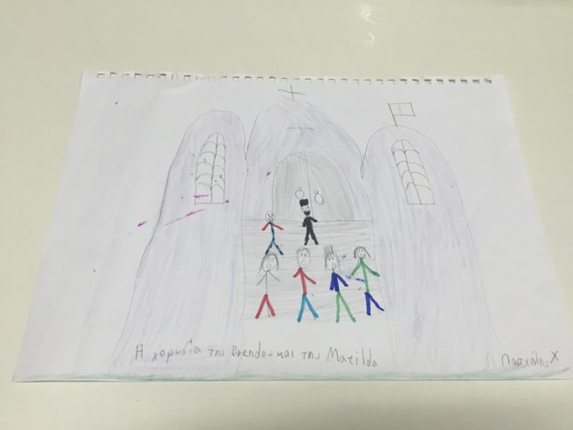

Pupil's painting about this story

2nd SESSION (4 hours)
Subject: Talking about peace
Aim :
- To mobilize the interest and the feelings of the pupils about peace
Objectives:
- Processing and annotation of the poem: "Peace" of Giannis Ritsos
- Formulating questions and highlighting the student's feeling about the poem - Discussion
- work creatively, in order to cultivate creative thinking
Method: exploratory learning
Teaching procedure:
- Reading and commentary of the poem - Discussion
- Artistic expression activity: Paint images of the poem about peace
- Dedicate greeting cards to children who perished in the Holocaust (Remembrance Day)
- Creative writing: Write a poem for peace
Materials:
  - Laptop, video projector
  - Whiteboard - markers
  - Cartons of red and gold color cut into heart shape
  - Sketch block
  - Colored markers
  - Excerpt from the poem: "Peace" of Giannis Ritsos ↓
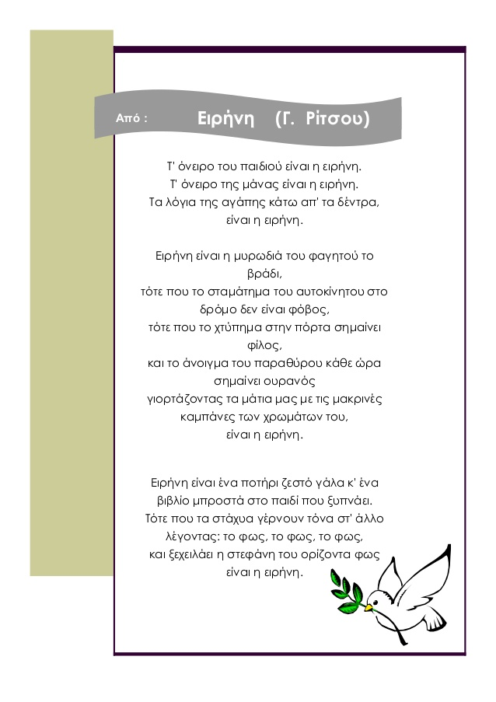

Paint images of the poem about peace :
" The child's dream is peace..."

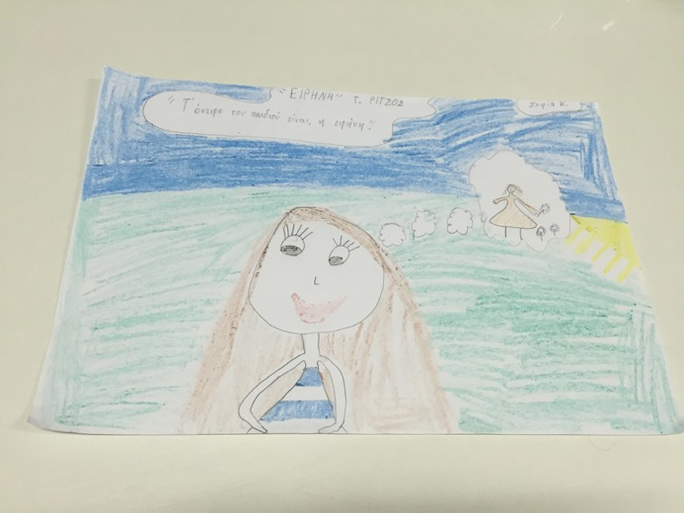

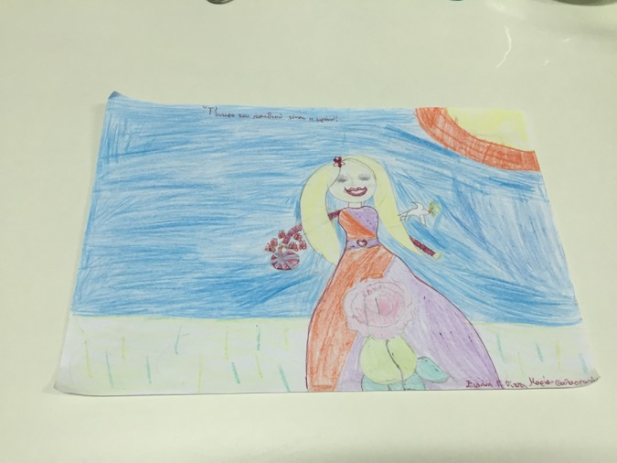

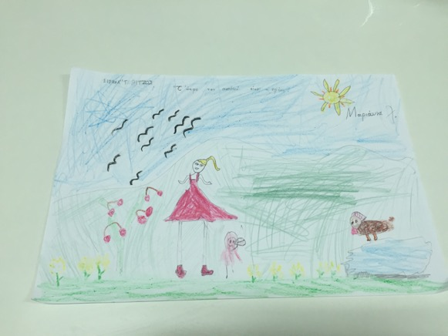

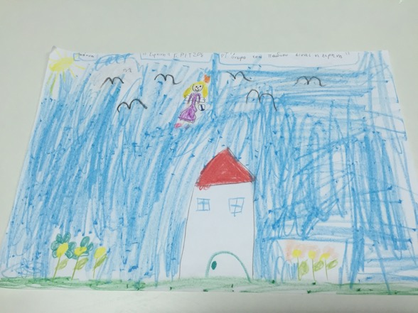

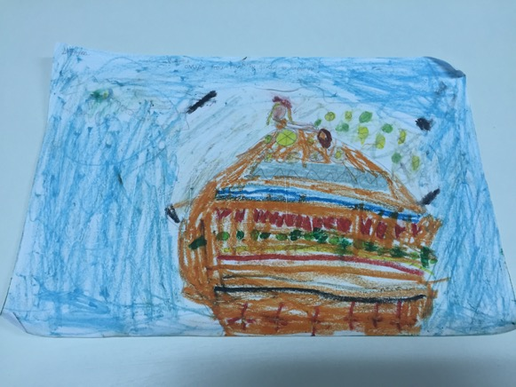

" Words of love under the trees is peace..."
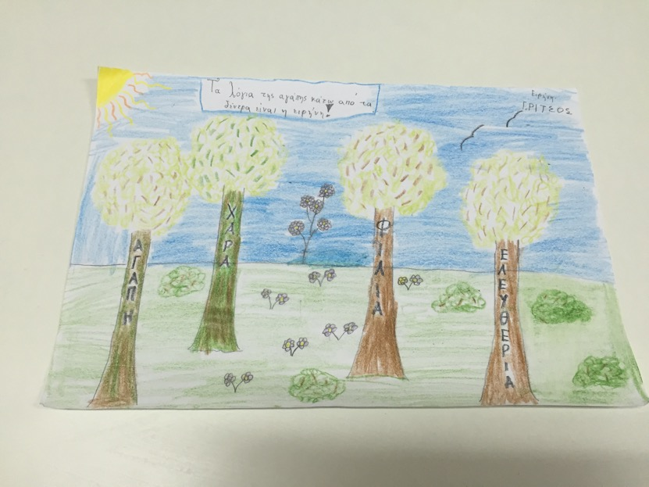
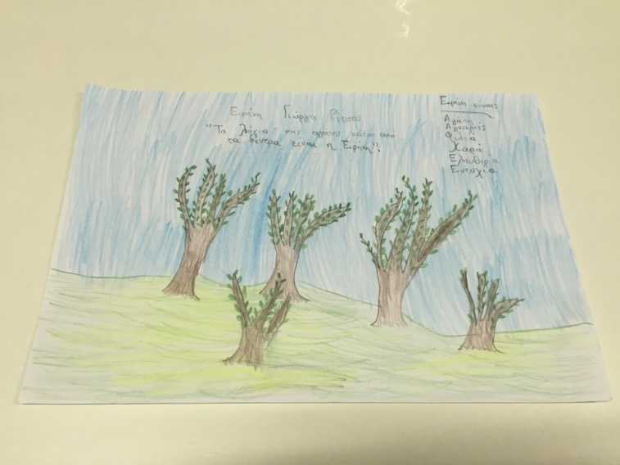

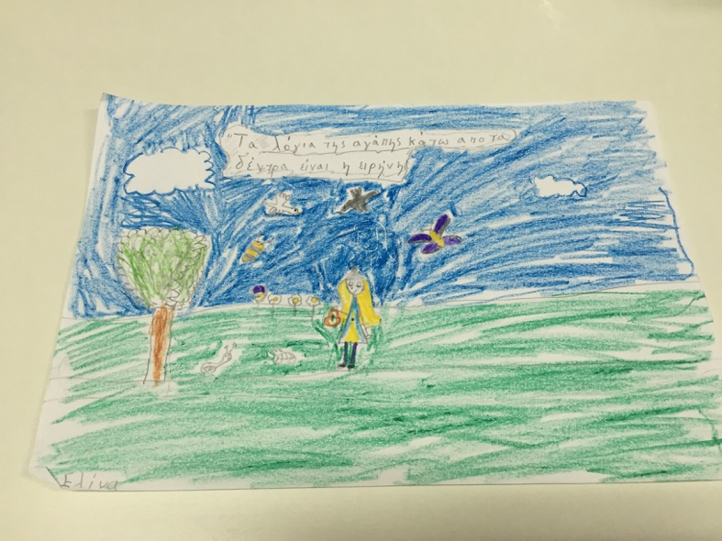

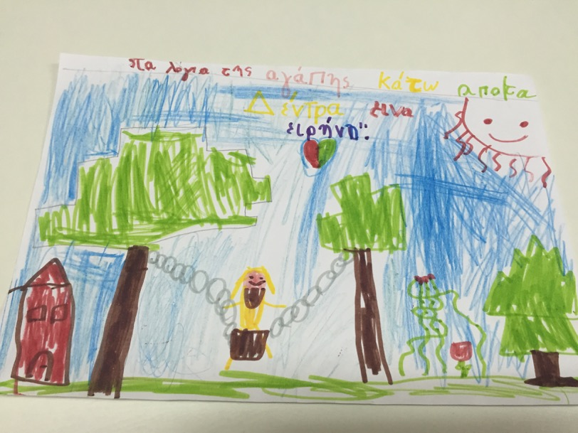

Poems for Peace:

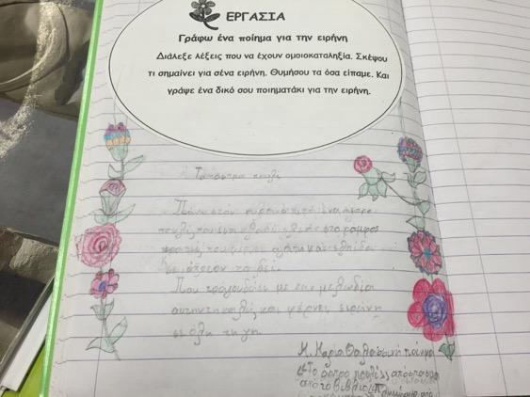
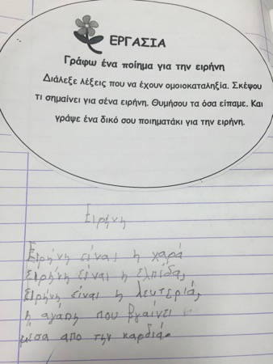
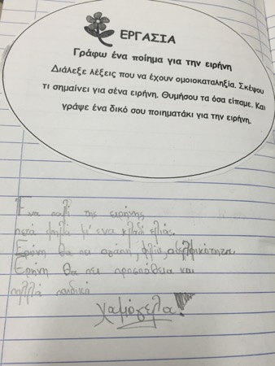
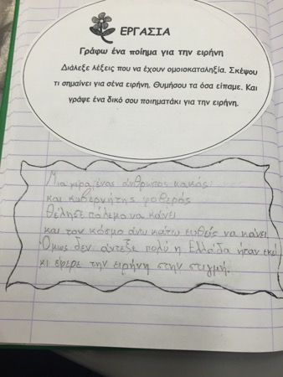
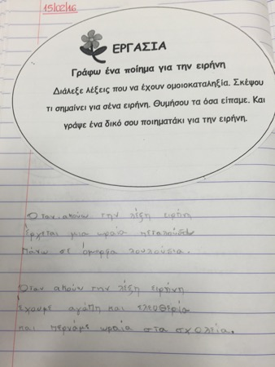
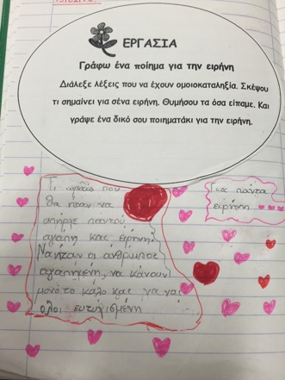
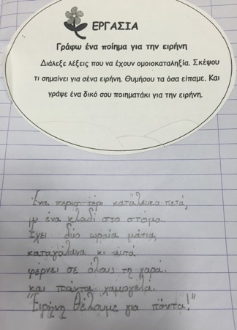

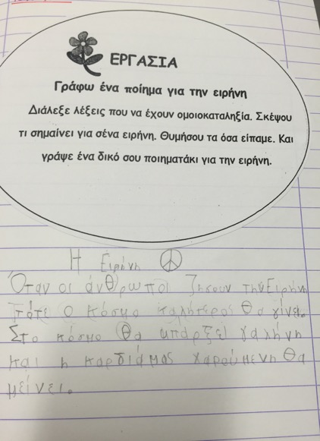
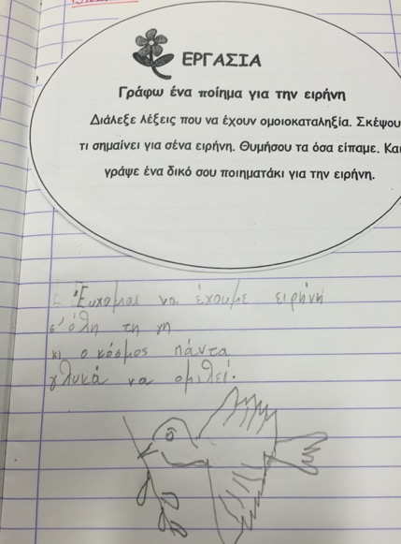
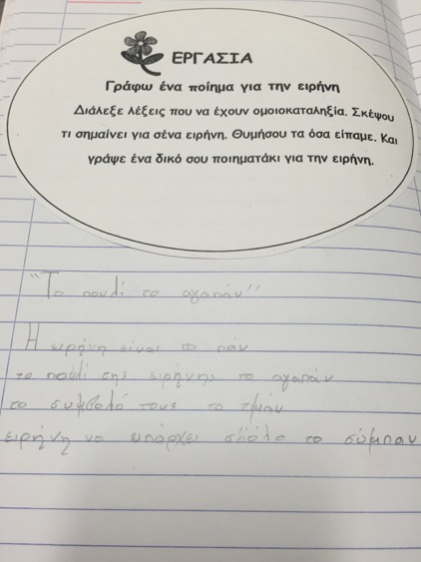
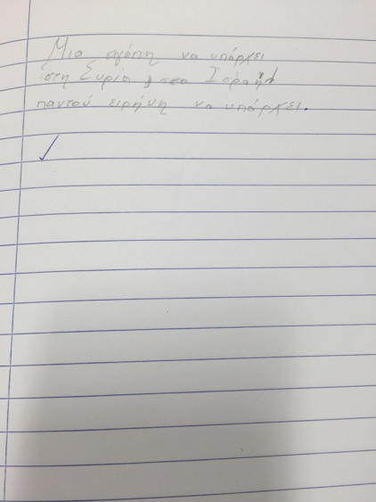

Tree of the wishes and the Peace
(Remembrance day - 27/01/16)
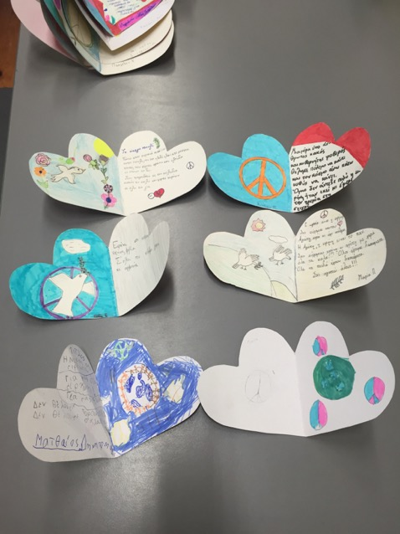
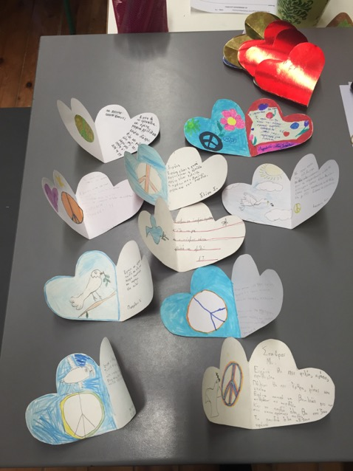
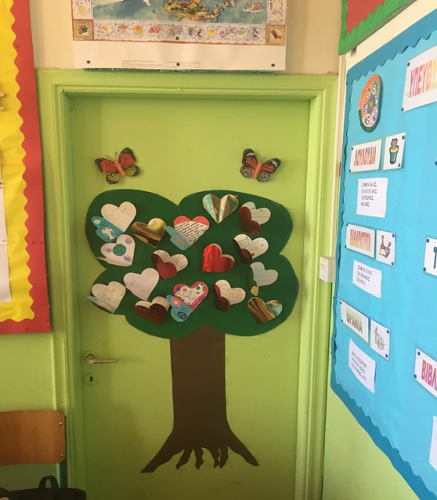

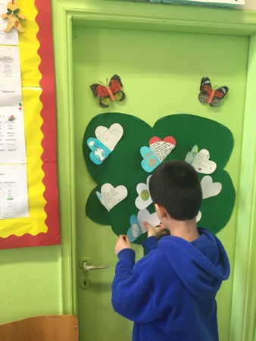
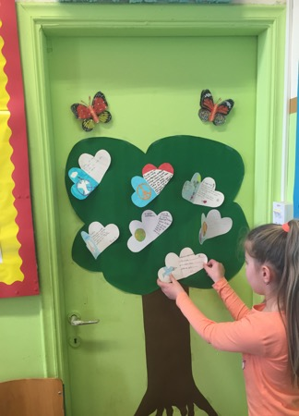
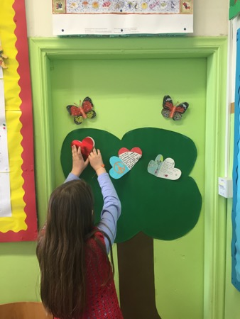
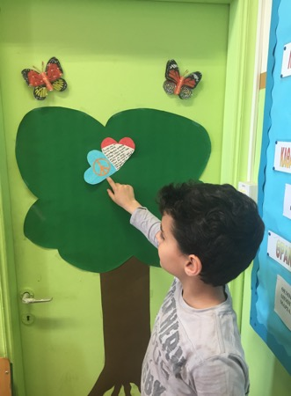
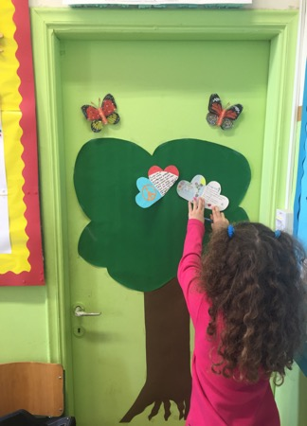

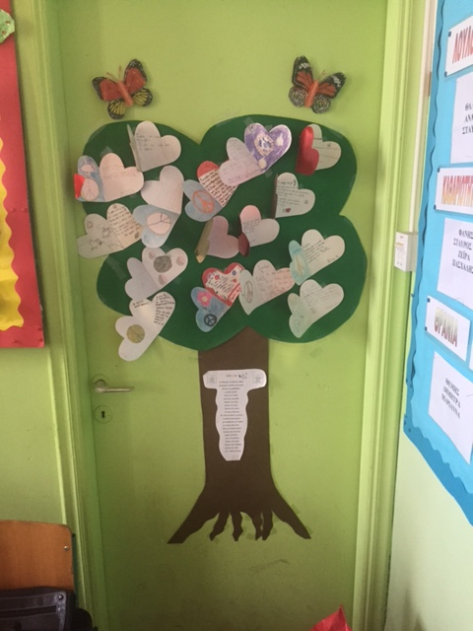

Philanagnosia
Ιντζίδης, Ε., Παπαδόπουλος, Α., Σιούτης, Α. & Τικτοπούλου, Α. (2015) Τα απίθανα μολύβια – Γ΄Τάξη (πρώτο τεύχος). Αθήνα: ΥΠΕΠΘ.
Πάρδο – Ασσέρ, Ρ. (2008). 548 ημέρες με άλλο όνομα. Αθήνα: Εκδόσεις Γαβριηλίδης.
Morgenstern, N. (2011). I wanted to fly like a butterfly. Jerusalem: Yad Vashem.
Morgenstern, N. (2011). I wanted to fly like a butterfly. Jerusalem: Yad Vashem.
Πάρδο – Ασσέρ, Ρ. (2008). 548 ημέρες με άλλο όνομα. Αθήνα: Εκδόσεις Γαβριηλίδης.
Doctor Karakotsos, recognized years later by Yad Vashem as Righteous among the Nations.
"The Holocaust and Greek Jews" Mandoulide's School
Κόκκοτας, Π., Αλεξόπουλος, Δ., Μαλαμίτσα, Α., Μαντάς, Γ., Παλαμάρα, Μ., & Παναγιωτάκη, Π. (2010) Μελέτη Περιβάλλοντος – Γ΄Τάξη. Αθήνα: ΥΠΕΠΘ.
Skovroneck family, recognized years later by Yad Vashem as Righteous among the Nations.
Morgenstern, N. (2011). I wanted to fly like a butterfly. Jerusalem: Yad Vashem.
Philanagnosia
Plant of Flowers by Chaim Nachman Balik "In the window there blossoms a plant. All day it peaks out at the garden. All its friends are in the garden; it stands here alone".
Philanagnosia
Such as respect, life, team spirit, peace, happiness, friendship, love, laugh e.t.c.
Philanagnosia
Excerpt from the poem, which is in the book of Ritsos, G. (1984) Poems 1941-1958. Volume Β', Athens: Kedros publising).

