Annotated Teacher's Version

My Family and My Roots: A Film Project
Student Project Guide 2018
Student's Guide and Teacher's Notes
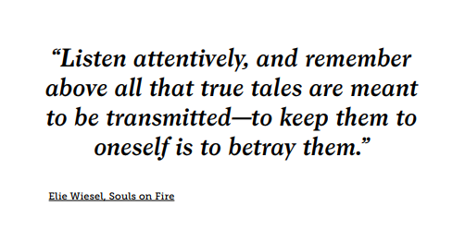
Introduction
This year, for your Roots Project, you will create a film that focuses on either of the following:
- the life of an older family member
- a film that traces your family history through several generations and ends with you (if you like).
NOTES FOR THE TEACHER
This guide was originally created for students to take them through the process and procedures of creating a family history film for our 9th grade Roots Family Project.
This annotated version for teachers aims (and hopes) to provide supplementary information to the Student Project Guide as well as to offer suggestions for teachers who are new to undertaking this project with their classes.
I have cited this quote from Elie Wiesel, found in the Centropa Source Book Volume One, to highlight one of the essential aims of the project – to help students convey a story, a personal story, a family story.
Hopefully, creating these personal stories will draw them closer to their own family stories, and develop an appreciation for the lives of people in previous generations – how they lived, where they lived, what life was like, and what many of them were forced to endure.
In addition, in viewing the films of classmates, I hope to
- foster an understanding of the lives of people unrelated to them
- help them develop empathy for others
- encourage a feeling of compassion and understanding
- learn to evaluate why people were motivated to do particular things and to
make decisions they made
The Introduction offers a preview to the project, some words about the "final product", and notes of encouragement to students who may have never made a video film before.
I believe it's helpful to look at this together with your students to calm any initial fears students may have about venturing into this "unfamiliar world".

In my experience, questions come always up at the beginning. However, one can detect that many of these questions spring from their initial concern: "Can I actually do this? Can I really make a film?" Knowing this evokes a smile and words of reassurance on my part.
PowerPoint Presentation Teacher's Guide
I would also ask teachers to refer to the comprehensive PowerPoint presentation that I have prepared and presented to teachers. The PowerPoint presentation can be used in parallel with this Annotated Teacher's Version of the Student Project Guide and, as a "visual guide", it presents many things about the project in a nutshell.
The presentation takes the teacher step-by-step through the practical procedures of film making and shows how materials available on the Centropa website can serve as learning tools and aids during the process.

Your final project will be in the format of a digital film. It will be a blend of family museum, historical archive, family album – and, hopefully, with dedication and imagination, it will turn out to be a genuine tribute to your family and to members of your family.
What the "final product" will look like.
We will discuss details in the guide, but, in a nutshell, your film will have what all films have: visuals and text - images, music, narration of a text, and a film script that you will write.
To create your Roots Family History film, we will be tapping into all the resources available to you, but we will also frequently refer to the website of Centropa, the historical institute dedicated to preserving 20th century Jewish family stories from Central and Eastern Europe and the Balkans, as well as Greece, and Bulgaria.
Centropa is also an educational institution, as its resources, stories, films, and interviews are directed towards students and teachers with a clear eye towards the classroom and the greater world of education.

TEACHER'S NOTES
Introducing Centropa: the organization, using its website and sources.
I introduce students to Centropa in the initial stages of the family film project because of the wealth of materials available on the website that can serve students when they work on their own films.
We use Centropa to:
- view the life stories of other people
- provide background into history and historical events
- fashion a picture of what life was like for Jewish people in Eastern and Central Europe before, during, and after WWII
- create a feeling of empathy and understanding about people we have never met but whose stories are touching, compelling, and often redeeming.
- model our own films with a mindful eye to script writing, visuals and images, sound, narration, flow, and film techniques
Note that Centropa's focus is not solely on the lives of Jewish people who lived in Eastern and Central Europe, but it also includes stories of Jewish people from Greece, Bulgaria, and the Balkans, home to thriving Sephardic Jewish communities for centuries.
Naturally, we will be using a variety of sources to gather our information, but as models for your film, we'll be turning to numerous biographical films on the Centropa website. We will not only use the films as models to study the technical aspects of making such family films, but we'll also view them because so many of them tell compelling, interesting stories. Our own engaging with the people in the films - their lives, their hopes, their choices, and their fates – should be of great help as we shape our own stories and films for others to see.
There is a great deal on the Centropa website that can help guide you through the process, and there is no question that it can prove to be a very “useful tool”. Its information and resources, as noted before, can serve as a wonderful model for your own project, and I recommend that you refer to the website as much as possible.
Centropa as a tool.
There is much more on Centropa and its website in the sections that follow below.
For now, take a brief tour: http://www.centropa.org
Looking at the Centropa website and Home Page.

Getting started
Collecting information from your family
Before you start planning your film, you have to gather a wide variety and a great deal of source materials that we will sometimes refer to as “documents” and “documents of all kinds”. You may need a good deal of help from the “older generation” – parents, grandparents, aunts, uncles, cousins. Ask anyone and everyone for help because they probably know more about your family than you do and have access to more information as well. Ask as many questions as you need to ask of anyone you can.
TEACHER'S NOTES
I usually begin the family history project several months before the final due date.
One of the reasons for this is to give them time in the computer lab in school so I can "be by their side", to assist them, answer questions, provide advice about sources, to help iron out any difficulties that might arise in the beginning, to answer any questions, to provide direction and guidance - generally speaking, for me to see that they are on the right track.
They'll need a good deal of guidance in the initial stages because they will have to continue working on their own time at home.
Another reason the project is spread out over several months is to give them time to speak to relatives and to locate information: photos, documents, certificates, letters, albums, to conduct research, etc.
In addition, we also explore the Centropa website during these initial computer room meetings to familiarize them with the content, with stories, but also, as said earlier, to provide them with examples of models for their own films.
After some time working at home, usually several weeks to a month, I give them a week's notice that we are going to go back to the computer rooms to continue. I let them know that I expect that they will have made progress on the film.

During this time, I send via e-mail a questionnaire (in chart form, see attached document, "2018 A Work in Progress: My Roots Family History Film Project", that they fill in and send back updating me on their progress – research, gathering information, etc. I write my comments or respond to their questions in red and send it back to them.
It's very important to check in with them now and then – and for them to know this - so they look at creating the film as an ongoing process and not something they can just do in the computer room or wait until the last minute to complete.

Documents and source materials
TEACHER'S NOTES
Types of Primary and Secondary Source Materials
- What to gather
- What to look for
- What to look at
- Whom to speak to
- ALL kinds of photos: family and friends, everyday events and activities, friends, class photos, houses, graduation pictures, wedding pictures, traditions, holiday celebrations, vacation pictures, shopping, markets, nightlife, leisure activities, work, school, military service, memorials, headstones, monuments
- Locations: cities, towns, villages, rural areas, lakes, rivers, countryside, fields, farms, etc.
Internet for photos
Locating historical and/or current maps
(see section below about maps)
- Official Certificates: birth certificates, marriage certificates, military certificates, property deeds, employment certificates
- Diplomas: high school, special courses, college and university, vocational, professional
- Awards, medals, citations, commendations, etc., from military and civilian life
- Travel documents: passports, visas, laissez-passer, immigration certificates, exit visas, etc.
- Identification documents – personal IDs, military IDs, property deeds, documents of ownership
- Personal family letters, diaries, albums, invitations, announcements
Use a good scanner for all the above so the scans will come out sharp and crisp.
- Personal collections that tell something about a person: stamps, coins, toys, etc.
- Others: ________________________________________________________________
_______________________________________________________________________

TEACHER'S NOTES
First, it is important to take high quality photos and/or make high resolution scans that will look crisp and sharp when they are inserted into your film.
Remember that the more a photograph, document, certificate, etc. is enlarged, the more it loses resolution and sharpness.
Naturally, when the film is projected for audience viewing, this could impact upon the quality of the images in the film they view.
If a scanner is not available, scanner apps are now available for smartphones. By scanning instead of photographing, the entire document will be in focus - if done carefully.
Using a smartphone's camera
If they use a smartphone camera to take photos, they should be sure not to create shadows.
In addition, the photo should not be taken at an angle, otherwise part will be in focus and part won't because of the depth-of-field issue.

NB: For the project, scan the photos and documents and save them for later (and perhaps, even, multiple) use. When you scan and save the photos and documents, give them names or coded numbers so you will know where, when, and how to use them in the film.
TEACHER'S NOTES
Organizing work: Images taken with a smartphone automatically get a .jpg number, but students should give the .jpg a name to make it easier to catalogue and retrieve them at a later stage in making the film.

Further information
You will have to gather a good deal of information about your family or about a person who will be the focus of the film.
Look at the chart below. Use this one or make your own and just brainstorm words, terms, names, places, etc. – whatever comes to mind – just to get the process going and the ideas flowing. (You will probably need to make the chart larger.)
What do I already
know about the subject?
What more would I like
to know?

Refer to the source materials section above: Ask about family and friends, everyday events and activities, routines, foods people ate and foods they ate on special occasions, school activities and school life, subjects studied in school, graduation ceremonies, wedding events, bar mitzvah and bat mitzvahs, family traditions and customs, holiday celebrations, vacations, sports activities, business activities, leisure activities, hobbies, military service, the origin of your family name and what it means, how your family got its name.
The Interview: Focus on a family member
If the focus of your film is on one family member, try to interview that person.
Devise a set of questions or a questionnaire that you will then use to interview a member of your family. In this way, you will find out specific information about your family and its history that you can use for the script of your film. Use ideas from the brainstorming, “Getting acquainted with the project topic” section. Try to prepare at least 10 questions.
When you interview the person, remember that sometimes the person's answer to a question may lead you make up another one on the spot. Let the interview flow. New questions sometimes come right from the answers to previous questions. Be open to this and don’t stick solely to the original list of questions. Also, be patient and give the interviewee time to answer your questions.
Your film should eventually show photos and images of the interviewee. In that way, the person comes alive for the film viewers and what we have learned about the person and your family now has a very personal face.
TEACHER'S NOTES
Conducting an Interview
This is the added value of an interview:
When a grandparent shares stories of her or his life at 14 or 15 years of age with a grandchild also at 14 or 15 years of age, one can only imagine the emotional bond that is created and strengthened. (I say this again later.)
Here are some tips and pointers to help students when they interview a family member for information.
It's important for them to understand that even if they come to the interview with a set of questions, those questions should be opening questions. Answers given by the interviewee should spark other spontaneous, follow-up questions that flow naturally and logically from the answers.
For example, if one question says, "What sort of games did you play?", the next question should not be "Where did you go to school?" but should flow from that answer. In other words, advise students to use the answer to the question about games to ask additional questions about games – who played them, boys, girls, what ages, what was needed, where were they played, etc.
I try to encourage them to gather as much information as possible to create a real picture of childhood, to keep asking questions from the answers they get, to see the person being interviewed not as an "old person" but as someone who was young once, went to school, played games, got into mischief, and later, perhaps even had to use their wits as they faced changing historical circumstances.

Remember, the film is not an interview and so we will not see the person sitting there talking throughout the film. The film may have photos of the person you through time, but the purpose of the interview is to gather information and to recreate a story, a story of a childhood, of growing up, of adulthood.
TEACHER'S NOTES
There is another purpose, other than gathering information, for interviewing the subject of the film, a family member – and I have learned this while reading reflections students have written or by them telling me this after they have created the films.
Sitting and interviewing a person for this "task" has effect of bringing them closer together emotionally, something that usually does not happen when one merely asks the person some of these questions in passing or on the run.
I recall that during a feedback session after we completed the film project, some students said that it gave them new insights about their grandparents and of how, in addition, they became emotionally connected to and engaged with their stories.
Again: When a grandparent shares stories of her or his life at 14 or 15 years of age with a grandchild at 14 or 15 years of age, one can only imagine the emotional bond that is created and strengthened.
Family information to include in your film
Before we can understand the “drama”, we must create the stage where the drama takes place. This involves looking at the historical, political, socio-historical, and socio-economic situation of the places from where your family came.
First of all, you will also have to carry out some research about the nation, region, or community from where they emigrated. You need NOT include an extensive history of the place, but instead paint a picture of what life was like there and how conditions might have persuaded your family to leave and immigrate to Israel.
Next, for a more personal look into understanding why your ancestors left places where they had been living for a long time, you will have to ask your own family members questions. Again, refer to the areas and subjects in the source materials section above.
TEACHER'S NOTES
Students should really understand that no story takes place in a vacuum but that historical, political, socio-historical, and socio-economic forces and conditions where the story takes place have an enormous effect and influence upon the course of events and thus, in people's lives, their options, choices, directions, and destinies.
Asking family members questions. I encourage family participation in the film project to the extent that family members can provide information about people and events that are relevant to the film. In addition, older family members may have access to documents, photographs, awards, etc.

Gathering Information and Conducting Research
You will also have to conduct some general research for the script of your film. The Internet has an abundance of resources to help you find information. I can recommend several that I think are outstanding for our project.
TEACHER'S NOTES
Locating Information
Historical accuracy is an important part of the film project and they should be encouraged to get their facts straight and accurate.
CENTROPA has digitized 22,000 photos and has made more than 40 multimedia films that are available for viewing. As you may not have personal family photos you would like to use to show a town, city, village, market, modes of transportation - ocean liner, railroad, automobiles, horses and wagons - famous persons, famous events – go to the Centropa website and conduct a search.
If you don’t have an old photo of a town or city back in, say, the 1890s, or the 1910s, or the 1930s, and you feel it really belongs in your film, try the Centropa website. Then use your screen capture program if you come across a shot you would like to keep. (The Snipping Tool, available in Microsoft Windows, also works well.)
YAD VASHEM is the world’s most well-known site for information, resources, and photographs related to the subject of the Holocaust and Jewish life in Europe prior to the Holocaust.
The archives at Yad Vashem contain the largest collection of Holocaust documentation in the world: 125 million pages of documentary evidence, films, 420,000 photographs, and more than 100,000 survivor testimonies.
In addition, the library at Yad Vashem comprises over 112,000 titles in 50 languages of Holocaust-related publications and a collection of about 4,000 newspapers and periodicals, many from the Holocaust period.
The site is comprehensive in its scope, rich in its information, and user-friendly. Log on here: http://www.yadvashem.org
Another excellent source of information is the website of the UNITED STATES HOLOCAUST MEMORIAL MUSEUM, located in Washington, D.C. You can log on here to access a wide variety of historical background, information, and photographs about Jewish life in Europe before WW II and, of course, during the Holocaust: http://www.ushmm.org/
The website of the JEWISH VIRTUAL LIBRARY states that it is “the most comprehensive online Jewish encyclopedia in the world, covering everything from anti-Semitism to Zionism. There are more than 16,000 articles and 7,000 photographs and maps that have been integrated into the site.” The large offering of maps is available and could prove to be very useful to you. This is the website: https://www.jewishvirtuallibrary.org/
BEIT HATFUTSOT - the Museum of the Jewish People (in Tel Aviv) and MyHeritage.com have collaborated on a major project to preserve Jewish family trees. For three decades, Beit Hatfutsot has been collecting digital information on many topics, all aimed at preserving the history of the Jewish people.
TEACHER'S NOTES
The museum has expanded in the past few years and has greatly increased its digital collections of information, including documents and photos.
Its multimedia database includes genealogy, histories and meanings of surnames - over five million individuals have already been recorded in the ever-expanding database - communities, historical photographs, film, video, and music. The museum has also focused on the histories of particular Jewish communities and, for example, in 2016, there was an exhibition about the Jewish Communities of Austria from the Middle Ages, to the Modern Era, to the Contemporary Era, which included personalities, daily lives of ordinary people, and the city of Vienna. https://www.bh.org.il/
Check out the website http://tracingthetribe.blogspot.com/2009/12/saving-trees-myheritage-beth-hatfutsot.html - "Tracing the Tribe: The Jewish Genealogy Blog". Have a genealogy question? Send it to ask@tracingthetribe.com
Finally, there is a little-known treasure close to home, right here in Jerusalem – the NATIONAL LIBRARY OF ISRAEL. Information is available in Hebrew, English, and Arabic and among its offerings are the library, the collections, e-resources, a digital library, an education department, and a music collection. The website is http://web.nli.org.il/sites/nli/English/Pages/default.aspx
The screen shot that follows shows a portion of the Homepage of the National Library of Israel. Scroll across these headings for a more complete description of each.

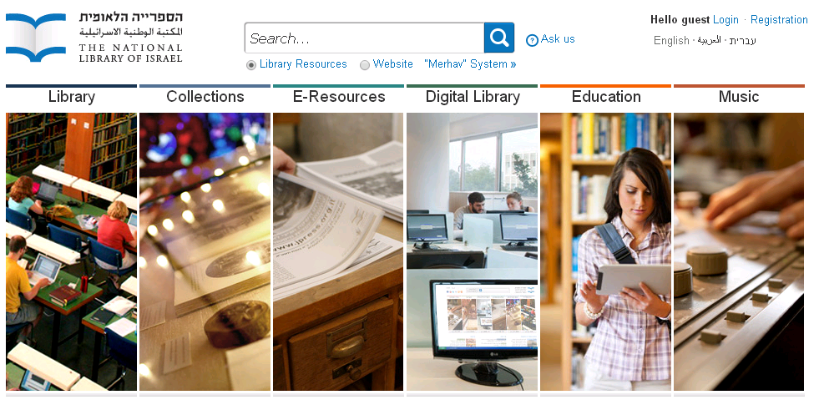
TEACHER'S NOTES
Website of the National Library of Israel
You can refer to the original Student Guide for what may be a better view of these images.
The National Library has also expanded its digital resources with a department devoted to education, educational materials, lesson plans, and suggestions how to approach and use educational materials, and how students can use the resources available.
I have students who have tapped into the very large collection of historical photographs available about Israel's early pioneering days, the founding of communities and towns, the Mandatory period, independence, and up to the present day. The collection runs the gamut of cultural images and images of everyday life.
In addition, students have gone into the music collection to use older music and songs as background soundtracks to illustrate specific village, town, and kibbutz scenes and to and compliment historical events with music.
The website is available in three languages – Hebrew, English, and Arabic, though the latter two are not yet as fully developed (i.e., translated materials) as the Hebrew site is.
(I have been told that they're working on it.)

MAPS
Maps provide us with an initial understanding of where events took place – where they began, where they played out, and where the events of people’s lives took them. Maps provide a picture of the "stage" on which historical events began and how they continue to unfold to the present day. Maps help trace family lives - where people were born, grew up, were educated, moved to, returned to (in cases), or where they finally settled and lived the rest of their lives.
Your film must include maps that are significant to your story and that show where events in your family took place. Also include maps that show where your family originated as well as places where they might have moved. Trace the routes of their journeys within those places as well as routes of emigration from and immigration to other lands in the course of your film. Finally, include maps in your project that trace your family's route(s) to Israel (or other places in the world), where they moved around within Israel, and where they finally settled.

The Internet has numerous sites for you to locate maps – current and historical. Be careful here: Use websites for historical maps, so when you show the origins or journeys of your family or a family member, say, back in Germany in 1932, in Poland in 1938, or in Libya in 1948, your maps are accurate reflections of how those nations looked during the years you’ve indicated.
You'll notice that maps are important features that appear throughout Centropa films.
TEACHER'S NOTES
I place a great deal of emphasis on including maps of all sorts in their family films for several reasons.
As I've written to students here, "Maps provide a picture of the 'stage' on which historical events began, followed a course, and how they continue to unfold to the present day."
The stories in their films take place over many years during which time, maps and borders change, names of places change, countries disappear, and new ones are born.
Another reason is that, just as historical accuracy is important and encouraged, so should geographical accuracy.
This is why I discourage the exclusive use of Google maps because they are present-day maps.
For example, in one film, a student wanted show that her relative, searching for family members who might have survived the Holocaust, had returned to Breslau (now Wrocław, Poland) after the war. However, she showed a current Google Maps version of Wrocław, complete with present-day route numbers 5, 94, 98, and 395.
A third reason is that I would simply like them to learn something about geography and history and to come away with some geographical competency, to enrich and expand their knowledge of geographical names and places and perhaps what they were, what they are now, and reasons for these changes.
There are a good number of websites on the Internet with historical maps and if they come across bumps in the road or have any questions, we are there to help.
This having been said, there may be only one a disadvantage to old, historical maps. Since they were printed maps, they often tried to pack as much information onto the maps as possible, of course, depending on the type of map it was. But oftentimes, these maps might include rivers and their tributaries, cities, towns, province names, mountains, etc. It's not out of the question that this "abundance" of information could confuse students who may not be used to these types of maps.
Many students are attracted to Google Maps because they are digital, convenient, and readily available, despite their historical inaccuracy for our purposes. One of the advantages of Google Maps is that as one zooms in to a specific location, more and more place names appear.
Still, I believe one should aim for historical accuracy, conduct a search, and use a screen capture program to capture the image of a map.

Using your materials
Remember the scans? Remember all the personal material you have on hand?
- Remember all the “documents” of ALL kinds, all the photos of people - friends and family, everyday events and activities, class photos, vacations, houses, graduation pictures, wedding pictures, vacation pictures, shopping, markets, nightlife, leisure activities, photos at work, at school, military service.
- Remember all the certificates - birth certificates, marriage certificates, military certificates, property deeds, employment certificates.
- Remember all the diplomas - high school, special courses, college and university, vocational, professional.
- Remember all the travel documents – the passports, visas, laissez-passer, immigration certificates, exit visas, etc.
- Remember all the identification documents such as work IDs, military IDs along with other types of documents such as property deeds and documents of ownership.
- Remember all the awards, medals, citations, commendations, etc., from military and civilian life.
- Remember other photos you can use to show location – cities, towns, villages, lakes, rivers, countryside, fields, farms, ports, harbors, monuments, memorials, cemeteries, etc.

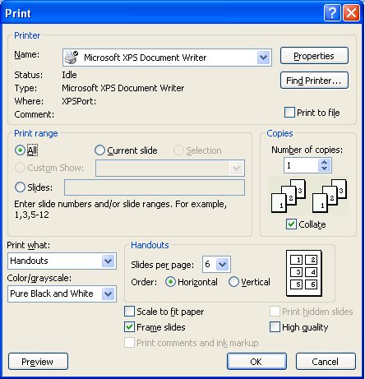
Making your film
Planning
Just as animators, cartoonists, and storywriters do, begin by creating a storyboard. Make boxes and sketch out or write what you would like to have in each scene.
Write instructions, directions, and notes for yourself about each scene. You can draw a chart with boxes or you can use PowerPoint to do this. Using the Print command, you can place multiple slides (4-6) on a page as Handouts and print them out. using Pure Black and White.
TEACHER'S NOTES
The screen capture shown here is provided as a suggestion of how they might plan their story using a storyboard. It's not a must but is only shown as an aid to help them plan out the story.
Writing the text and script
Gather all your photos, documents, maps in one place (one folder) and think about how you want your story to look. Place them in the order you think you would like to use them as you create the film.
Now, it’s time to start writing your script, using the resources and materials at hand – both from your family and from all the research you have conducted.
Keep in mind that you are telling us a story. The photos, images, maps, and all other visuals you use in the film are really there to “serve” the story line.
In previous sections of the project guide, we’ve talked about what kinds of subjects, topics, and areas to include in the text.
Also consider that history and the lives of the people in your family have a direct connection to one another and what happened in history influenced the “timeline” of the events in your own family’s history. In many cases, these events may have changed the life of your person, the lives of your family, and the paths in life they had earlier charted out for themselves.
Be sure that your film reflects important events that took place in the world or in your family’s town, city, region, or country.
Remember when you write your script, take some time to reflect on all the information and material you have collected. Sit down and look at everything. Take it all in. Take time to reflect and wonder. Keep in mind that the film you are creating and the script you are writing is their story but that most of all, it is also YOUR story.
Avoiding "Information overload"
There is a temptation, sometimes, include as many names, dates, and details in your script and in your film as possible. Be careful – do not "overpack" your film.
This is especially relevant when it comes to names of your family members and ancestors. Too many names can confuse the viewer, especially when we include this brother-in-law, that great uncle by marriage, this third cousin, and so on, so much so that, as we say, you can't tell the players without a scorecard. Think about this when you include the names of places as well. Does their inclusion in the film script help the film?
Of course, if you like, you can have an "animated" family tree or chart where names appear one at a time and where we do not have to process the relations and connections of an entire family all at once. Include names and people, yes, by all means, but ask yourself if they are relevant to the story and if including them serves your purpose. Again, avoid "information overload".
Avoiding "Image Overload"
Again, the script guides the text of the film and determines when pictures appear on screen, when they fade, when new ones appear, and so on.
Be careful: You do not have to illustrate every sentence, every line, or every event in the narrated script with an image taken from the Internet. Sometimes, these seem to fit the text, but they have no serious connection to the story. This could easily lead to "image overload".
We are looking at each family history film for the first time, and we need to carry out several "tasks" at the same time – follow the story, read the subtitles, figure out who's who, and understand the connections between people, places, and events. At the same time, we also need to process changing images and quickly understand how they are part of the story.
We want our viewers to concentrate on the story, on the narration, and on the content without too many images that could distract us.
Instead of inserting too many pictures and images - "image overload" - stay on one, zoom in zoom out, and let the subtitles and narration of the story guide the viewer.
There is a lot of content in each image and you should allow your audience to see what's there. Images serve the story – they are not the story themselves. It is perfectly alright to have an image on the screen for some time. Let your images fade in and out and when you want to show a new image create a smooth transition to the next image. It's restful to the eyes and your viewers will be able to follow the story.

An Important Note about Subtitles
When you begin making the film, place your subtitles on the bottom of the screen, just as you see in films and on TV. Proofread the writing. Spellcheck the writing.
Try to have no more than two lines for subtitles. If needed, simply go to the next screen to continue, keeping the same image on the screen if it's relevant.
You want your viewers to be able to read the subtitles.
Be sure that the subtitles appear on the screen and remain there long enough for someone to read. Read the subtitle twice yourself – that should give your viewer extra time to read the text.
Avoid fonts that are too difficult to read. Make them large enough to see and read, as many people in your audience will rely on them in the event they can't follow the audio narration quickly enough.
Note the background image where the subtitles appear. Sometimes, subtitles might be set against light backgrounds and sometimes against dark ones. White subtitles will be impossible to see in the former case and black subtitles will be impossible to make out in the latter case. One way of adding clarity and visibility to the text is to give the font a shadow. Try it. But always, in the back of your mind you should be asking: "Can the subtitles be read, and can they be read easily?" Repeat this to yourself as well: "I want my viewers to be able to read what I wrote. I want them to understand my film, enjoy my film, and maybe, even be touched by my film."
Again, remember that the text of the script – your subtitles - enables your viewers to follow your story as they read and as they alternate between reading, listening, and viewing.
Proofread and Spellcheck ALL OF YOUR WRITING – especially the subtitles.
A thought
Remember that, in some way, who you are is also because of who they were, who you are is because of what they believed, who you are is because of what they did, and who you are is because of what they wanted for their lives and for the lives of their children and grandchildren. Try to convey this sense to your viewing audience.
In some way, you may be asking, “Who am I because of who they were?”

TEACHER'S NOTES
Organizing and Writing the script
The script guides the film in the sense that it is the text of the film that students use when they narrate the film.
The text of the script determines when pictures appear on screen, how long they remain on screen, when they change and when other pictures (and maps) appear, and when there are pauses in the narration.
The text of the script appears as subtitles on the screen and enables viewers to follow the story as they read and as they alternate between reading, listening, and viewing. what the students use to narrate the film.
Before sitting down to write the script, there are several charts that I distribute to help them organize information and materials that they already have or know or that they need to find.

- "A Film Project Chrono-Organizer" (chart that helps them place events in chronological order, where the events took place, who was involved.)
- "Resource and Materials Checklist for the Roots Family Film" helps them organize materials and information
- "Organizing the Script and Planning the Film" (two-column planning chart helps students coordinate the script with images, music, audio, narration)
- Final Check – "Roots Family History Films - Final Checklist"
An Important Note about Images
Again, the script guides the text of the film and, therefore, determines when pictures appear on screen, when they fade, when new ones appear, and so on.
Images, of course, should be related to the text of the story, but I have seen students sometimes fall into a trap here. Here's how.
Some students think that every sentence, every line, or every event in the narrated script must be depicted with an image.
There are countless images available on the Internet that make it easy to insert images into the film, but there is no need to do this.
In fact, in my opinion and in my experience making these family history films with students, it is a mistake and a pitfall to avoid. It could easily lead to "image overkill" and I have seen this.
We are viewing each family history film for the first time, and we need to carry out several "tasks" at the same time – follow the story, read the subtitles, figure out who's who, and understand the connections between people, places, and events. At the same time, we also need to process changing images and quickly understand how they are part and parcel of the narrative and how they are relevant to the story.
Some people believe that because we are bombarded by images and quick flashing images, for example, on TV series (action or otherwise or on MTV or equivalents) with smooth-talking, glib-dialogued characters, and quick-shifting, shaky, "realistic" camera takes, we have all learned how to sort these images out and make sense of each and every one. I don't believe we have.
We want our viewers, instead, to concentrate on the story, on the narration, on the content without too many images that may actually distract us from the focus of the story.
Instead of inserting too many pictures and images - "image overload" – they can stay on one, zoom in zoom out, and let the subtitles and narration of the story guide the viewer.
There is a great deal of content in each image and students should allow their audience to see what's there. Images serve the story – they are not the story in and of themselves. It is perfectly alright to have an image on the screen and for students not to feel as if they might be boring their audience.
Tell them to let their images fade in and out when they want to show a new image; a smooth transition is restful to the eyes and keeps the viewer alert to the story.
An Important Note about Subtitles
Hopefully, the directions for your students regarding subtitles are clear. However, there are certain points about subtitles about which they should be reminded and that should be stressed and repeated. I've seen some very good films whose subtitles were a bit of a bust and which had an impact on the final, overall quality of the film.
Subtitles should be placed on the bottom of the screen, just as they see in films and on TV.
They should have no more than two lines each time subtitles appear on the screen. If needed, they can simply go to the next screen to continue, keeping the same image on the screen - if it's relevant.
Their viewers should be able to read the subtitles. They should appear on the screen and remain there long enough for someone to read. I once heard that a viewer should be able to read the subtitles two or three times before changing to the next set of subtitles. They can try this and time themselves in their movie making program – sometimes viewers need extra time to read the text. Better to let slower readers be able to read the text; faster readers can look at the images a while longer.
Avoid fonts that are too difficult to read. Make them large enough to read, as many in the audience will rely on them in the event they can't follow the audio narration quickly enough.
Note the background image where the subtitles appear. Subtitles might be set against light backgrounds and sometimes against dark ones. White subtitles will be impossible to see in the former case and black subtitles will be impossible to make out in the latter case. One way of adding clarity and visibility to the text is to give the font a shadow. But always, in the back of their minds, they should be asking: "Can the subtitles be read, and can they be read easily?" It's good to conduct a check before they "lock" and save the final version of the film.
Again, remember that the text of the script – your subtitles - enables viewers to follow the story as they read and as they alternate between reading, listening, and viewing.
Remind them about proofreading and spellchecking ALL OF THEIR WRITING – especially the subtitles. Misspelled words do detract from the film's quality.

Creating Your Roots Film Using the Centropa Website
CENTROPA: http://www.centropa.org/
More About Centropa
Centropa is a Jewish historical institute dedicated to preserving 20th century Jewish family stories from Central and Eastern Europe and the Balkans. The organization is headquartered in Vienna and has offices in Budapest and Washington, D.C.
Centropa’s banners say, “Preserving Jewish memory - Bringing history to life” and “Where Jewish history has a name, a face, a story”.
The website of Centropa is outstanding. It is both comprehensive in its scope and extremely rich in its information. It is very user-friendly and easy to navigate as its goal is to make its stories, photos, films, and interviews readily accessible to students and teachers. Its website comprises 1,200 interviews, 22,000 digitized photos, and 40 multimedia films.
Centropa’s website has programs, films, biographical information, photographs, and more available in English, Hebrew, German, Czech, Slovak, Bulgarian, Hungarian, Polish, Lithuanian, Russian, Ukrainian, and Romanian. It is a treasure trove of information.
Among Centropa’s aims are to connect students and teachers to the lands of Jewish heritage by creating programs about the entire 20th century – and not only about the period of the Nazi Germany and the Third Reich. Centropa wants to focus on and celebrate Jewish life - and not simply on the Jewish tragedy – as witnessed and so well-known during the Holocaust. Centropa also combats anti-Semitism and Holocaust denial by creating programs that students carry out themselves and share with other students worldwide.

Centropa holds an annual summer academy for educators from Europe, North America, and Israel and they are usually attended by upwards of 90 teachers from approximately 15 or more countries. Teachers work together on many topics and projects during the summer academy and continue to work together, along with Centropa, after the seminars and the summer academies. To date, Centropa has 600 partner schools in 16 countries.
In addition, smaller regional Centropa seminars are held during the school year in Europe, the United States, and in Israel. These seminars also bring teachers together - to work together, to share together, and to create together.

Navigating the Centropa website
Visit the Centropa website to become familiar with the abundance of resources and materials it has to offer. Scroll across the Menu bar, and then open each of the following topics: CENTROPA INTERVIEWS, FILMS, EDUCATION, to see what is available. Each one has a drop-down menu that takes you to a wide variety of subject matter and sources - films, interviews, biographies, etc. As on good websites, you have many links to other subjects and topics found on the Centropa site.
Try this. Click on EDUCATION.
The drop-down menu shows you three areas.

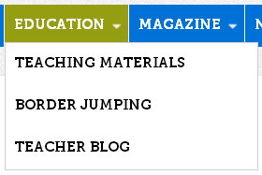

Now click on TEACHING MATERIALS to see what’s available.
The screen capture below shows you all the topics, themes, sources, etc. available in TEACHING MATERIALS under EDUCATION. Have a look through it just to see what you can access on the Centropa website.
Note that this particular screen capture also shows where you’ll be able to find information and instructions to help you create your Roots film.
(We will discuss more about accessing Making Movies a bit later.)

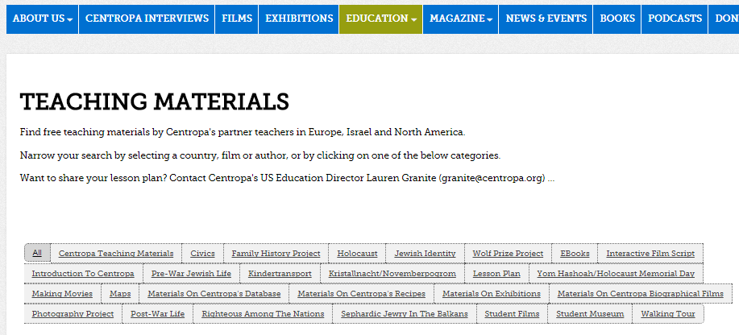
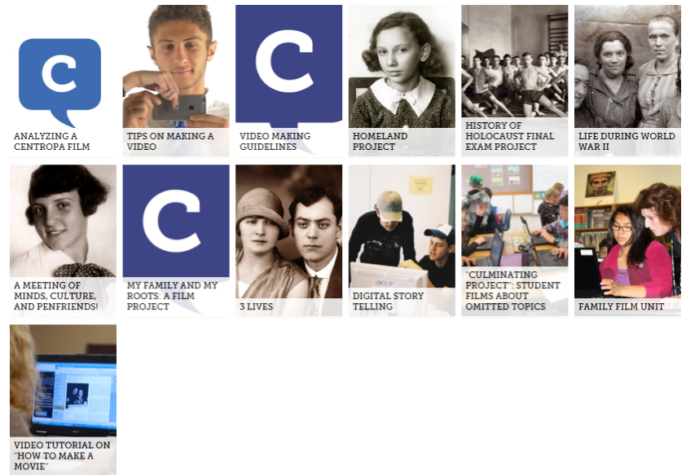

More About Navigating the Centropa Website: Centropa Films
Close-up: Finding films according to themes, events, or people
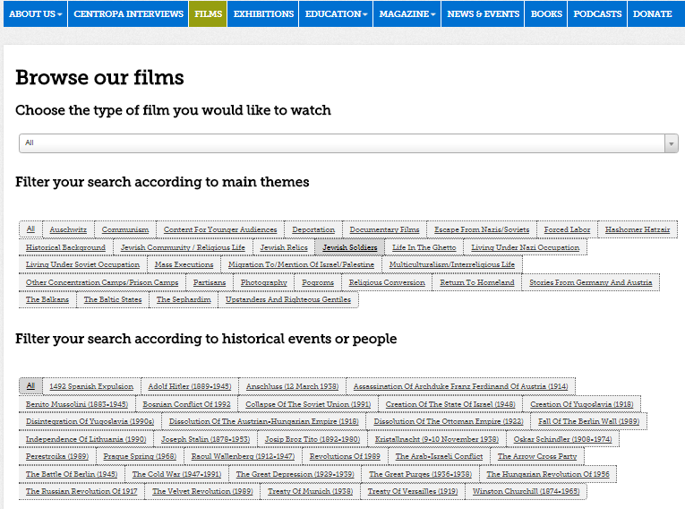

Viewing Centropa Films
It would be a good idea to select and view at least four Centropa films to get a feel for how you might like yours to look.
Many Centropa films focus on one or two people but as they tell their story, naturally, other people become involved and are also included in the story. These people are usually relatives and family members who raised them, who educated them, who guided them, and who instilled values and traditions in them. But there are also friends and acquaintances, teachers, employers, officials, people who helped them, and – yes – in some cases, even people who saved them.
Look at the screen capture that follows, showing the Centropa site where you can access 40 multimedia films.
You can also access the films using this URL: http://www.centropa.org/centropa-cinema
Look through the thumbnails of films on the site and select one to start off. You have a number of viewing options available and, in cases, you can select a language in which to listen to the narration of the film and a language in which to view the subtitles.

Try this. Click on the thumbnail, Maps, Central Europe, and History, seen in the screen capture below.

The screen below appears.

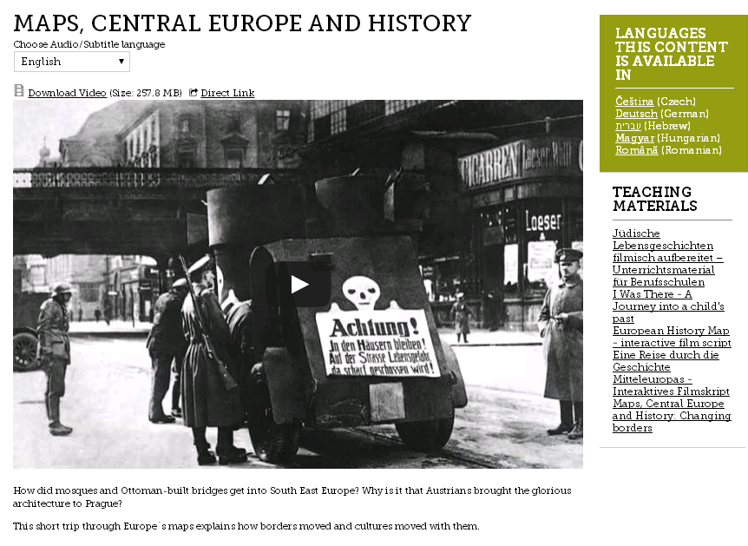
The information in the upper right-hand corner (green box) tells you the languages in which the film is available.

The field shown in the in the red circle in the upper left of the screen capture also allows you to choose several languages in which you can listen to the film or read along with the subtitles. Try it.
If you click on the down-arrow, the choice of languages for audio and subtitles opens. Try it. A close-up of the field appears below.

Here's another example of a film on the Centropa website, "SURVIVAL IN SARAJEVO -- FRIENDSHIP IN A TIME OF WAR".
You can listen to the film in any one of eight languages and view the film reading subtitles in any one of seven languages.

In addition, there is an introduction to the film, and off on the right side, for teachers, a hyperlinked list of Teaching Materials that can be accessed for lesson plans.
Below each film are details about the film, length of the film, and countries mentioned in the film.
Finally, there is a study guide and a film script for those who wish to read the script without viewing the film.
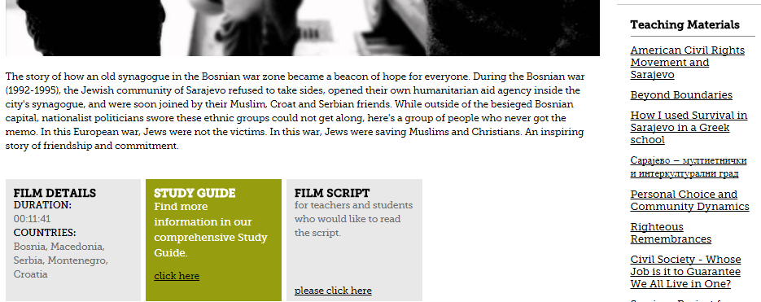

The Great Centropa Treasure Hunt
This Treasure Hunt is a hands-on introduction to the Centropa website.
There is a wide range of questions in the treasure hunt and finding the answers requires a careful search through the website, looking for key words, terms, names, places, photographs, events, etc.
As you answer the questions, you will have to navigate the website, which in turn will help familiarize you with all Centropa has to offer as you set about to work on creating your own film.

Viewing Centropa Films to help create your own
As you view Centropa films, listen to the story. Try to become involved in the person’s life, who she or he is, who was important to them, what happened to them, what they learned in life, and what you can learn from them.
At the same time, take notes and make your own observations not only about the facts of the story, but also about the techniques used to make the film and the subjects, topics, and events that were included in the film.
TEACHER'S NOTES
Briefly, and as a reminder, viewing Centropa films for the purpose of movie making helps students become familiar with how
- a film biography is written
- it is depicted in film
- it is narrated
- visuals, images, and movement are used
- music enhances the story and mood
- sound effects add “color”

First, make a note of how the filmmaker used scans and images of the “materials” in the film.
Look at how the filmmaker varied the scenes, used motion, moved pictures, made pictures and visuals fade in and out, etc. used music to create moods, to highlight events, or to provide background. (I can make some recommendations for music, though I am certain you have many songs of your own from which to choose.)
Look at how quickly or slowly visuals and images changed, and which ones were left longer on the screen.
Pay attention to how sounds and sound effects were used – and where and when they were placed in the film.
Pay attention to what the filmmakers included in the film. At the end of the film viewing, are there any questions that you have?
Keep this in mind: Are there questions about what was left out and perhaps why were certain things left out? The question of leaving things out is also an important consideration in making the film just as you have to consider what to include and why.
Listen carefully to the narration of the film because your own film will have to be scripted and narrated to synchronize with the visuals in the film. In many Centropa films, famous people in the world of theater, acting, and journalism narrate the films. Listen to how they use their voices. Also note how slowly and clearly, they speak. It's important for you to consider this because you must think about your own audience listening to the film – even if there are subtitles.
Who is narrating the film? Is it Nina Molho, the daughter of the “main characters” in the Centropa film “A Bookstore in Six Chapters” who narrates the story herself or is it someone playing one of the main characters and narrating the story in the first person as, for example, in “Matilda Kalef - Three Promises”?
“Who” will narrate your film?
TEACHER'S NOTES
As noted, I encourage students to view Centropa films for modeling their own, in addition, of course, to the content and tales themselves.
There are several films that lend themselves very nicely for them to view and think about how they might organize their own films.
One of the films I recommend for this purpose is the story of Renée Molho, “A Bookstore in Six Chapters”.
There is a chart I have prepared for students to use as they view the film and are asked to pay attention to the techniques used to make the film, the subjects, topics, and events that were included in the film, images, audio, voice, music, and narration.
The chart, entitled "Viewing Centropa Films 'A Bookstore in Six Chapters' is attached or will be made available on the Centropa website.
Another film, a longer one, a wonderful, touching tale of loss, courage, rebirth, and redemption is the story of Leo Luster, "The Past is Another Country." Apart from the story, the length of the film provides students with the opportunity to view a wide range of film techniques that they can use to model their own films.

Filmmaking information on the Centropa website
You can access info about film-making (making movies) by navigating through the Centropa website as shown above, or you can also access info at these URLs found on the Centropa website: Nick Holton’s “Digital Story Telling And The Holocaust” on the website as well as his video tutorial on "How To Make A Movie".
http://www.centropa.org/teaching-materials/video-tutorial-how-make-movie
The screen below appears when you click on the link.
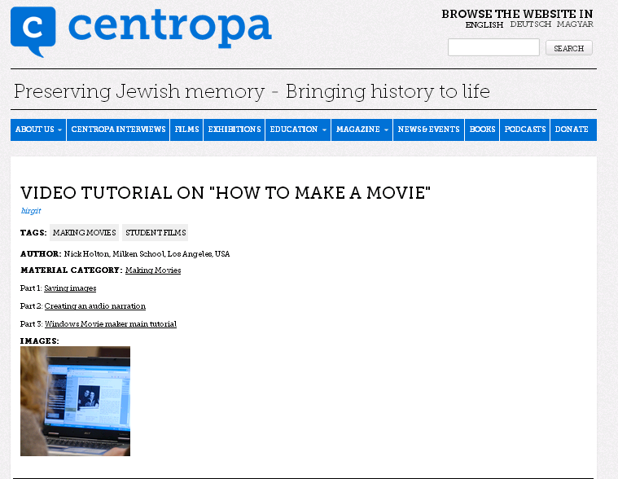
One of the most common digital movie-making programs is Microsoft Windows Movie Maker, and many feel that this is sufficient for most students. It's included in older versions of Microsoft Windows. A screen capture of the interface you first see if you choose to use Movie Maker, appears below.
In more recent versions of Windows, Microsoft has not included Movie Maker, but there are programs available on the Internet that perform the same tasks and carry out similar functions.
If it is not already installed on your computer, as of this writing, you can download it for free at the URL below as part of Windows Essentials Suite.
http://windows.microsoft.com/en-us/windows-live/essentials
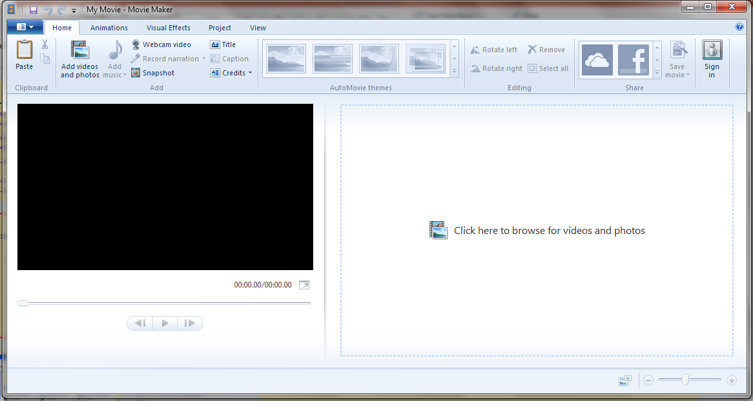
There are other digital movie-making programs available on the Internet; you only need to conduct a search. Two others are Sony Vegas and Apple iMovie.
Some digital movie-making programs are also available on the Internet for a free 30-day trial.
The Internet has many resources that allow you to choose, download, and include sounds to enhance dramatic moments or events in your film, such as a door slamming shut, a gate closing, a locomotive chugging, a whistle blowing, a steamship horn, troops firing weapons, etc.
TEACHER'S NOTES
Please note that by the time this guide hits the presses, some of the technology discussed throughout these pages may have changed or fallen victim to the ever-changing world of technology.

Screen Captures (aka Screen Shots)
A screen capture program allows you to capture and crop images and save them in .jpg format for later use. You can also pause films and use the screen capture program if you come across a shot in a film that you would like to use.
Microsoft Windows includes a free screen capture program called "Snipping Tool"; it is very easy to use and, most of the time, you only need to use the most basic functions it has to offer.
If you would like a somewhat more sophisticated screen capture program, you can probably download one from the Internet; some of them, however, are not entirely cost-free.
One program is called FastStone Capture and it’s downloadable from the Internet.
People who know how to work with PhotoShop may also want to use the program to cut and crop pictures.
Remember that it is important to take high quality photos and make high resolution scans that will look good when they are moved into your film.
Important reminder: Give these captured images names when you save and catalogue them in your files; they will be much easier to locate later when making the film.

Some more tips (thanks to Centropa)
- Make sure your software allows you to “Import” the materials you have collected.
- Import all materials so that you can arrange them into an organized film.
- Your software will have a “timeline” or a “project area” where you can arrange your materials to create your film.
- Consider performing your narration first at the speed and tone you wish and then add the materials.
- Once your narration is complete, add your images, audio files, music, video clips (if any), and sound effects.
- Proofread and Spellcheck ALL OF YOUR WRITING.
- Remember to save FREQUENTLY during the movie making process!

Additional Info about Genealogy
As mentioned earlier, MyHeritage.com and Beit Hatfutsot - the Museum of the Jewish People - have put together a project to preserve Jewish family trees. For three decades, Beit Hatfutsoth has been collecting digital information on many topics, all aimed at preserving the history of the Jewish people, including family trees with millions of records. Its multimedia database includes genealogy, surnames, communities, photographs, film/video, and music.
Check out the website http://tracingthetribe.blogspot.com/2009/12/saving-trees-myheritage-beth-hatfutsot.html - Tracing the Tribe: The Jewish Genealogy Blog
Have a genealogy question? Send it to ask@tracingthetribe.com
There are also many other genealogy websites on the Internet and all of them help you create family trees.

Final Steps (thanks to Centropa)
Film Credits
Your film must have closing credits, just as all films do.
At the end of the film, give yourself credit and list all the names of people who helped in the production of the film, who helped in the research, in interviews, in gathering documents, etc. Thank anyone and any organization that also helped. Give credit where credit is due. Be generous.
Be sure to list the places and organizations from where you got your information – websites, museums, organizations, educational institutions, map sites, etc.
Provide URLs for websites.
You may also wish to dedicate the film to someone or to some people.
If your credits "roll", be sure to do it slowly enough for the viewers to read.
If your screen credits fade in and out, again, be sure you do it slowly enough for the viewers to read them.
Look at the end credits of Centropa films to see how you can do it.
Save your film as a .MOV or an MP4 file.
Save the finalized version to your computer. You can copy it to a DVD-R, a disk-on-key, or you can load the film onto YouTube making it instantly available to your family, your classmates, and to the world.

