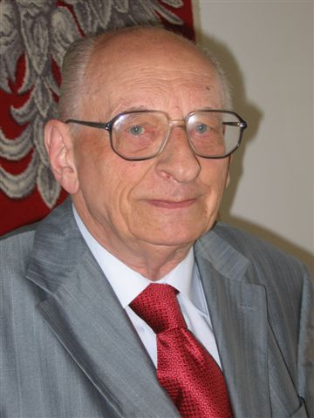
Bartoszewski was a contemporary (modern) witness and victim of Nazi Germany, someone whom no one expected to become involved in bringing about reconciliation (peace) between the countries.
And yet it was people like him that ultimately made it possible for the two neighbors to grow closer together.
When asked about his good relationship with Germany, the former Auschwitz prisoner said:
"If someone had told me in 1941, while I was standing on the parade ground in Auschwitz,
that I would have German friends one day,
I would have called him mad." But several decades later, Bartoszewski was considered in Germany
as one of the people who had worked hardest for this friendship.

"Wherever I talk to people, I try to bring them closer together and to fight against stereotypes. I see that as my mission." Władyslaw Bartoszewski always stood up for people. At just 18 years of age, the Pole joined the resistance against the Nazis and helped persecuted Jews. During a police raid against Polish intellectuals in September 1940, he was taken away to Auschwitz Concentration Camp from where he returned
seriously ill in April 1941.

Wladyslaw Bartoszewski survived Auschwitz, then joined the underground Polish Home Army, fought in the Warsaw Uprising and helped to rescue thousands of Jews. After the war, he worked as a freelance journalist and was frequently arrested by the communists. He supported the Catholic opposition and the trade union movement Solidarność. After 1989, he was twice made foreign minister. Despite his advanced age, he was active right to the end, most recently as an adviser to Prime Minister Ewa Kopacz and government coordinator for German-Polish relations.
"Wladyslaw Bartoszewski witnessed first-hand what people are capable of - both good and bad," German President Joachim Gauck said on the occasion of Bartoszewski's 90th birthday in Bellevue Palace. But this doyen (senior) of Polish politics was far from classing moral status according to national categories. "It is worth being ethical" he said.
For many years, Wladyslaw Bartoszewski watched how Germany deals with its history. He was interested in how the country came to terms with its past, and in the question of guilt. His attitude to the subject was also known in his native country. There, too, he caused quite a stir over some taboo topics, such as the approach of contemporary Poland to anti-Semitism during the Second World War.
Władysław Bartoszewski died in 2015 at the age of 93.
